Project report
Introduction:
Statistical learning includes a vast set of tools that helps us understand and interpret the data in a better and more precise way. These tools are divided into supervised and unsupervised learning categories.
- Supervised learning: supervised statistical learning involves building a statistical model for predicting, or estimating, an output based on one or more inputs.
- Unsupervised learning: with unsupervised statistical learning, there are inputs but no supervising output; however, we can still learn something about the relationships, structure and patterns of the data and make insights about them.
In this project, both supervised and unsupervised learning techniques were applied to the data set. Two different datasets were chosen for the two approaches:
- For the unsupervised learning part, the dataset used is a dataset about “smartphones” that was retrieved from Kaggle and it’s in a csv format.
- For the supervised learning part of the project, instead, the “breast cancer” dataset was used, because it has a target variable, which is “diagnosis” and so it fits better the aim of the supervised learning approach, in respect to the “smartphones” dataset we have used in the unsupervised learning part. Also, this dataset, was taken from Kaggle and it is in a csv format.
Unsupervised learning
Unsupervised learning uses machine learning algorithms to analyse and cluster unlabelled data. These algorithms discover data grouping or hidden patterns without the need for human intervention. It’s ability to discover similarities and differences in information makes it ideal for exploratory data analysis, cross – selling strategies, customer segmentation, and image recognition (from IBM website).
Dataset
The dataset used for the supervised part of the project consists of 980 observations and 22 columns, which represents various characteristics and technical specifications about different types of smartphones (in particular, each row is about a different smartphone model like Iphone, Motorola etc ……). This dataset includes various attributes of the phones such as brand name, 5G compatibility, memory characteristics, battery information, price of the smartphones and so on.
These are all the variables that are present in the dataset:
- Brand name: the name of the brand that produces the smartphone (like Samsung, Apple, Xiaomi and so on……)
- Model: this variable contains the specific name of the model of the smartphone
- Price: indicates the price of the smartphones in Indian Rupees (INR)
- Avg_rating: it’s the average rating of the smartphones given by the customers
- 5G_or_not: it’s a binary variable that indicates the presence or not of the 5G connection support on the smartphones (Yes = 1, No = 0)
- Processor_brand: which is the name of the brand of the processor implemented in the smartphone
- Num_cores: it’s the number of the cores that are present in the CPU of the smartphones
- Processor_speed: it’s the speed of the smartphone’s processor, measured in GHz
- Battery_capacity: it’s the capacity of the battery of the smartphone, measured in mAh
- Fast_charging_available: as avg_rating, also “fast_charging_available” is a binary variable where 1 indicates that the smartphone supports fast charging and 0 indicates that the smartphone does not support fast charging
- Fast_charging: the speed of fast charging of the smartphone measured in W
- Ram_capacity: the number of GB a smartphone has for its RAM (Random Access Memory)
- Internal_memory: the number of GB of the internal memory of the smartphone
- Screen_size: it’s the size of the screen of the smartphone expressed in inches
- Refresh_rate: the refresh rate is the measure of how many times the display updates in each second, and it is measured in Hz
- Num_rear_cameras: represents the number of rear cameras that are present in the smartphone
- Os: represents the operator system like IOS, Android ……
- Primary_camera_rear: resolution of the main rear camera in (MP = Megapixel)
- Primary_camera_front: resolution of the main front camera (MP)
- Extended_memory_available: it’s another binary variable which is 1 if the smartphone supports the expansion of the storage through an external memory, and 0 if the smartphone doesn’t support it
- Resolution_height: it’s the vertical pixel resolution of the screen of the smartphone
- Resolution_width: it’s the horizontal pixel resolution of the screen of the smartphone
So, the aim of this part of the project is to apply unsupervised learning models and techniques in order to identify relationships, hidden patterns and possible grouping of the different types of smartphones that are present in the dataset. To do so, after the exploratory data analysis, different unsupervised learning techniques are going to be applied, such as clustering, k- means hierarchical clustering and PCA (principal component analysis).

Exploratory data analysis (EDA)
First, it’s better to understand what really EDA is. Exploratory data analysis (EDA) is used to analyse and investigate datasets and summarize their main characteristics by also employing different kinds of data visualization methods and techniques. EDA is important because it helps to determine what is the best way to manipulate data sources to get the needed answers, making it easier to discover hidden patterns, identifying anomalies, test some assumptions and to check if they are correct. The most important objective of Exploratory Data analysis is to help us to understand the data and comprehend various relationships within the data and gain insight about the data itself (source: IBM).
After understanding what exploratory data analysis really is, we can begin with the description of all the passages of the exploratory data analysis. First, it’s important to verify if there are any missing values in the dataset. In fact, in the dataset used, several missing values/null values were found and afterwards they were removed by using a listwise deletion. In addition, verification of the presence of duplicates was made and as it can be seen from the results, there were no duplicates in the data. In this dataset, as said before there were several null values, so na.omit ( ) method was applied to drop them. After the elimination of the null values, by verifying the distribution of the values of the variables by using the table ( ) command, it was noticed that the variable fast_charging_available, it became constant since all its values are now equal to 1 as we can see below:
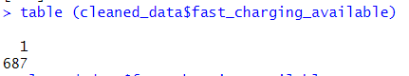

So now, this variable has no variance among its values since its constant, so it doesn’t contribute in any way to the analysis, so it has to be dropped. This probably occurred because the rows that had the value of fast_charging_available = 0 were probably affected by the missing/null values in other columns such as fast_charging. The other binary variables like extended_memory_available and X5G_or_not retained variation because, on the opposite way, their values were not concentrated in the rows that contained missing data in the data set.
After the cleaning of the dataset, the first step was to identify the numerical variables in order to go on with the analysis and distinguish them from the categorical ones. To explore the distribution of the variables in the dataset, several graphical representations were created in order to show the distribution of the variables among the data set and to understand better the data set itself and find hidden patterns and relationships between the data and the influence they have between each other. From all the following plots X5G_or_not and fast_charging were excluded since they are binary variables and it’s not useful to see their distribution.
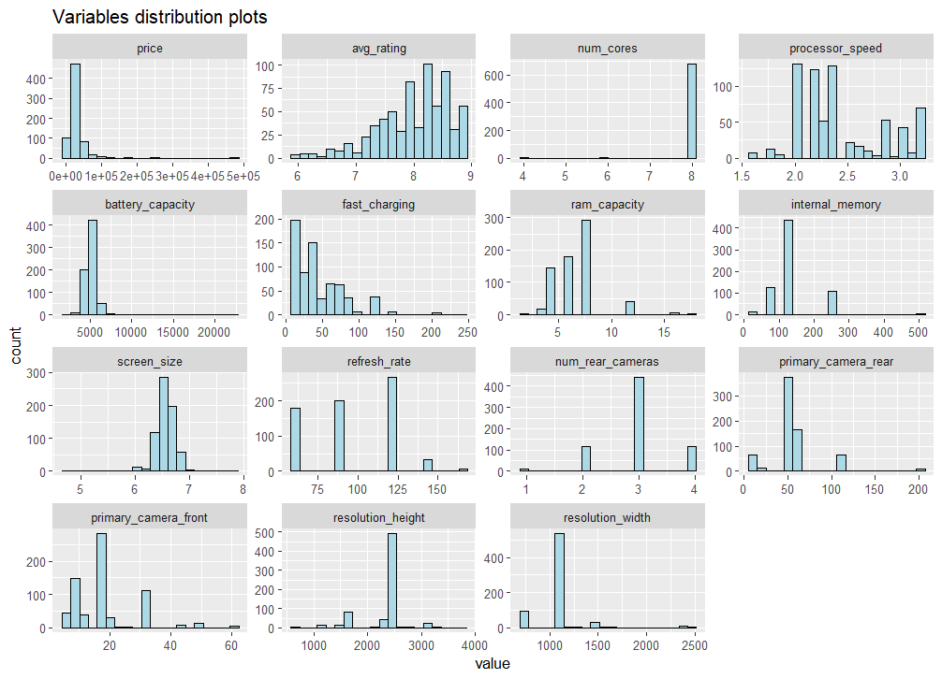
First, histograms of all the numeric variables were created and grouped together in order to have a general understanding on how the variables distribution is across the dataset and to understand if there is the presence of outliers and if some of the variables present some skewness.

Some of the variables like “price”, “battery capacity” and “fast charging” are right skewed, showing a major distribution among the smaller values and a long tail along the bigger values. It has to be noticed that some of the variables like “5G or not” and “extended memory available” were counted as numeric for plotting purposes even though they are not numeric but categorical in nature (they contain values 1 and 0) and they only represent the presence or absence of a feature in the smartphones analysed.
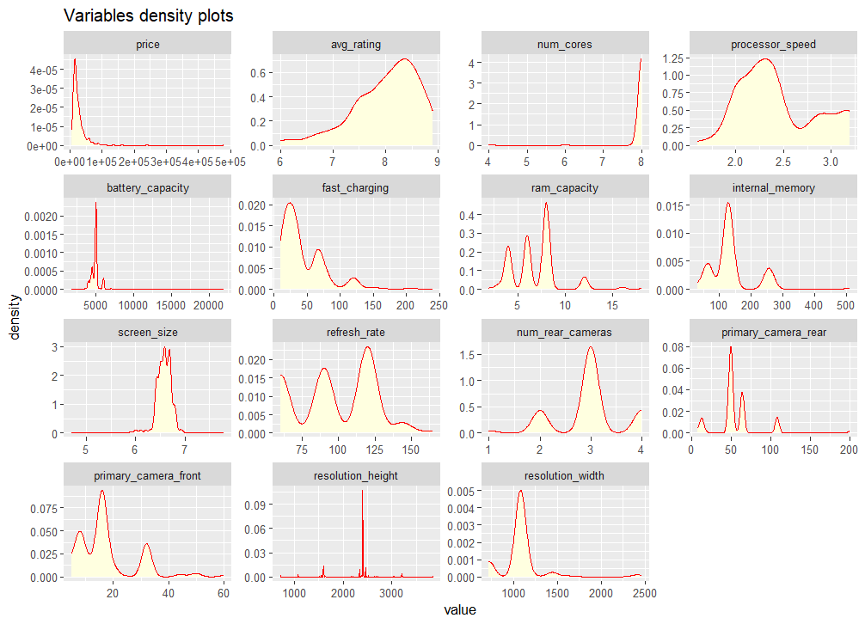
Afterwards, also density plots of the numeric variables were generated, to permit a clearer view and understanding on how the distribution of the variables is spread across the dataset. Afterwards, they were combined with the histograms.

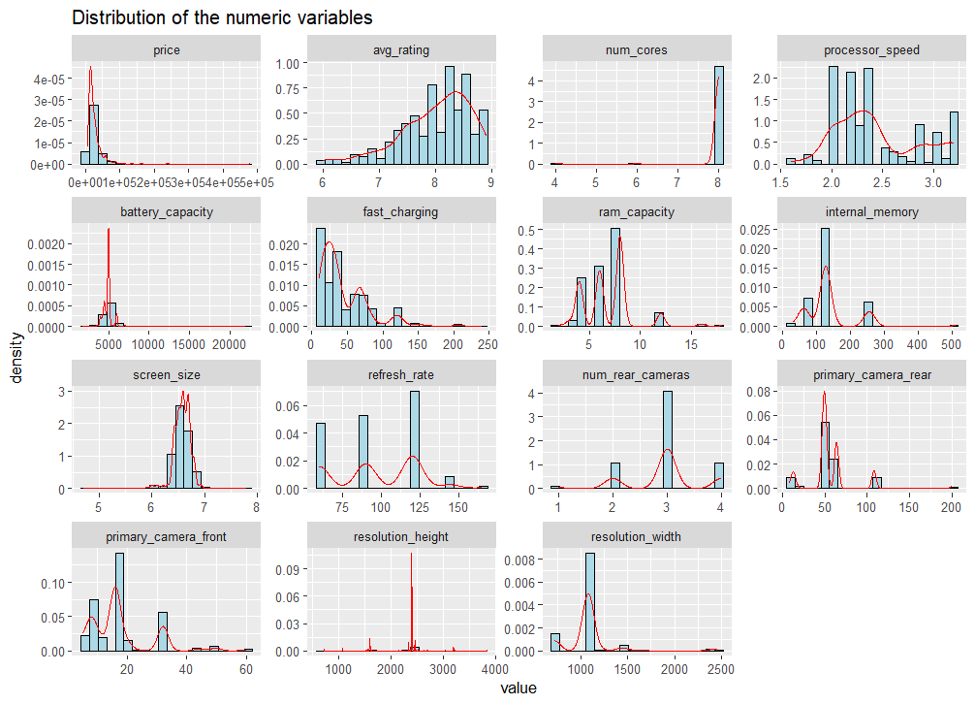

After a clearer comprehension of the variable’s distribution of the dataset, several relationships between the variables were analysed to make some insights about the data:
- RELATIONSHIP BETWEEN AVERAGE RATING AND BRAND NAME:
To explore consumer satisfaction, the average rating of the smartphones for each brand was computed by combining the brand name of the smartphones and the mean of the variable “avg_rating” for each brand group. To see in a clear way the relationship between the brand name and the average rating given by the consumers, a bar chart was computed. An as it can be seen from the plot, the highly rated brand by the customers is Lenovo, followed also by Asus and so on. This means that Lenovo by mean, received more positive reviews than the other brand’s smartphones. This is an important data to understand the preferences of the customers in the smartphones market.
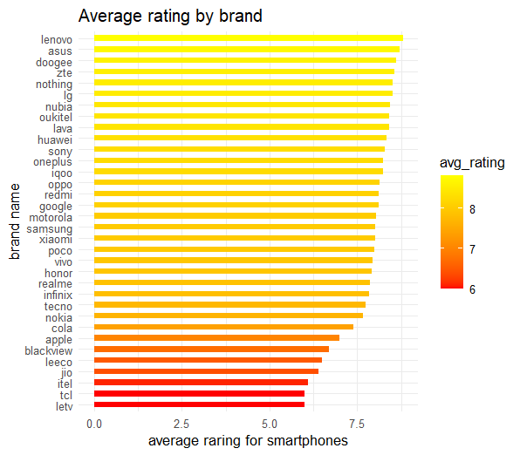

- RELATIONSHIP BETWEEN BATTERY CAPACITY AND PRICE OF THE SMARTPHONE:
To see if the battery capacity has any effect on the price of the smartphone, a graphical representation was made by using a scatter plot with a fitted linear regression line. As it can be seen from the plot, there is no positive correlation between the battery capacity and the price of the smartphones; on the other hand, it can be observed that there is mostly a small negative linear correlation between the two variables, meaning that it’s not always true that a higher battery capacity corresponds also to a higher price of the smartphone in the market but in can be also the inverse, so that a smartphone with higher battery capacity has lower price than a smartphones with smaller battery capacity. These negative relationships can happen because the price of the smartphone is not influenced by only one feature, but by a lot of features that can contribute to the rise of the price and so, it means that the battery capacity it’s not a strong predictor of the price of the smartphones, even though it contributes to it as well.

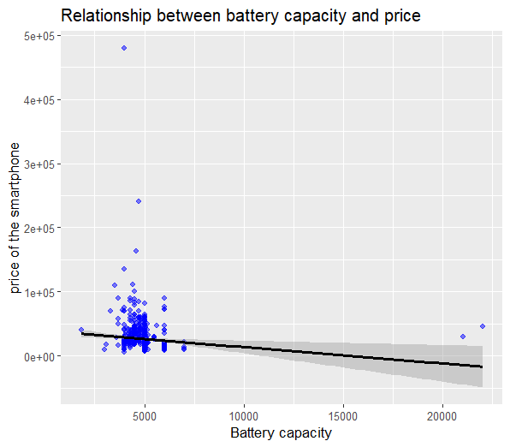

- RELATIONSHIP BETWEEN NUMBER OF SMARTPHONES AND BRAND NAME:
We can use this relationship to see which brands have the highest number of models listed in the dataset. From the bar plot in the figure below, we can see that the highest number of smartphone’s models is detained by the brand Xiaomi, followed by Samsung and Realme. This suggests that these three brands have a broader product range in the dataset, though this does not necessarily reflect user preference or popularity.

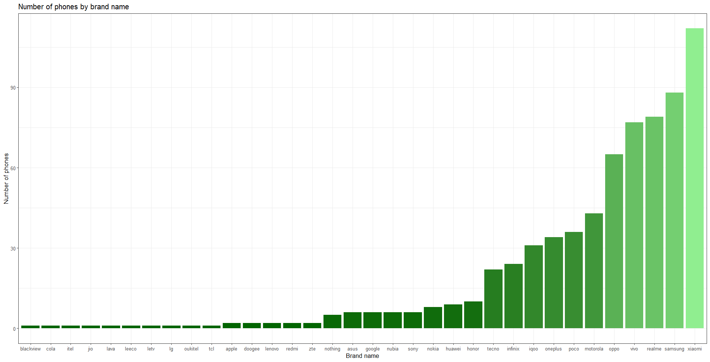

- RELATIONSHIP BETWEEN NUMBER OF REAR CAMERAS AND THE NUMBER OF SMARTPHONES:
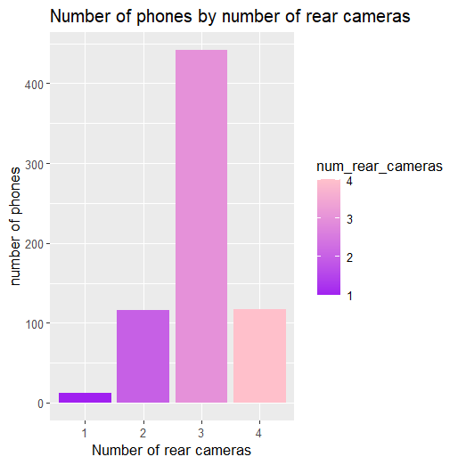

The plot shows the distribution of smartphones based on the number of rear cameras. As it can be seen from the bar plot, most of the smartphones, have 3 rear cameras on them, and most of the other phones have 2 or 4 rear cameras. This tendency, demonstrate that there is a trend in the dataset to produce smartphones with more rear cameras, maybe also to get a greater resolution of the photos taken with the smartphones. So, this plot highlights the trend of the dataset to have smartphones with a greater number of rear cameras implemented on them. After doing so, the relationship between the price and the number of rear cameras can be studied.
- RELATIONSHIP BETWEEN PRICE AND NUMBER OF REAR CAMERAS:
To understand if there is a clear relationship between the number of rear cameras per smartphone and the price, the average price was calculated for each group of smartphones based on the number of rear cameras. The results were then visualized using a bar plot.
As it can be seen from the plot below, smartphones with 3 rear cameras have the highest average price, while those with only 1 rear camera have the lowest average price. This suggests a trend where smartphones with more rear cameras tend to have higher prices. However, the relationship it’s not perfectly linear. In fact, smartphones with 4 rear cameras have a lower average price in respect to the ones with 3 rear cameras. This means that the number of rear cameras contributes to higher smartphone prices, but it’s not the only factor affecting the increasing of the price, as we can see by the fact that 4 rear camera phones have a lower average price then the smartphones with 3 rear cameras. Other characteristics, such as brand, hardware specifications, and additional features, likely play a significant role in determining the final cost of a smartphone.
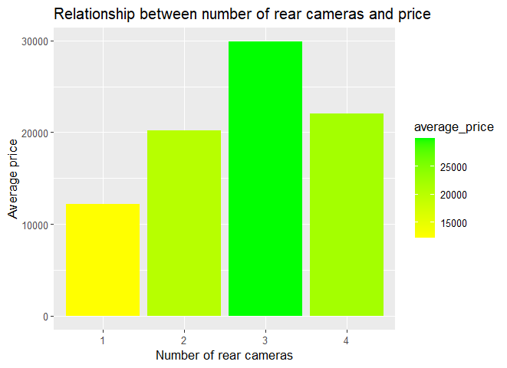

- WHICH BRAND OFFERS THE HIGHEST NUMBER OF REAR CAMERAS?
After determining the number of rear cameras by brand, a bar chart was used to visualize the number of rear cameras by brand and show which brands offer the highest number of rear cameras. As it can be seen from the plot below, several brands like Zte and Xiaomi offer the highest number of rear cameras (the maximum number of rear cameras in the dataset is 4). This may suggest that these brands focus more on providing more advanced camera setups to the consumers, to give a greater quality of the photos that can be taken from their devices. On the other hand, the brands that offer a lower number of rear cameras may prioritize lower prices and the simplicity of their smartphone’s models or may have different design strategies.
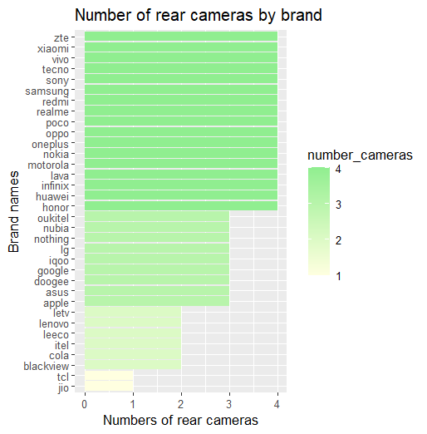

- NUMBER OF SMARTPHONES WITH 5G AND THE RELATIONSHIP BETWEEN THE PRESENCE OF 5G AND THE PRICIES OF SMARTPHONES
First, to determine the impact that the presence or not of 5G in the smartphones has on their prices, it is necessary to count the number of smartphones with 5G per brand.
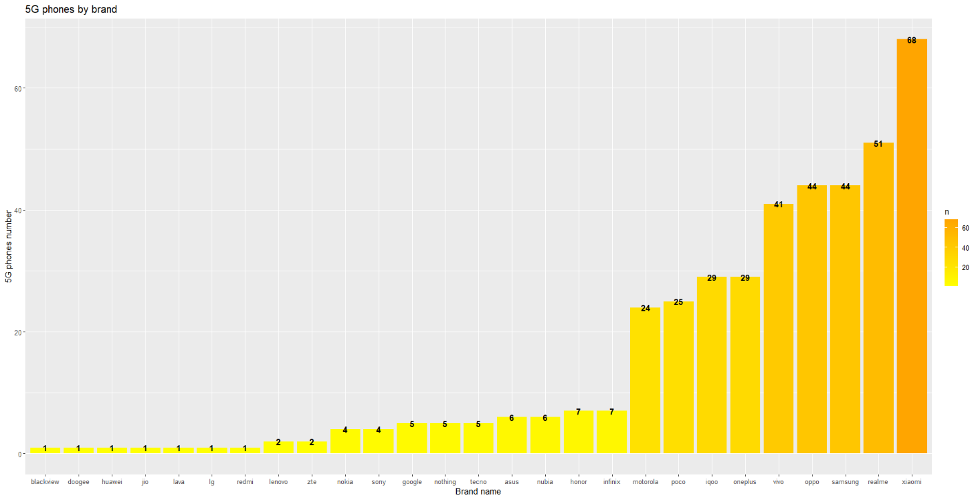

From the bar chart, we can see that the brand that offers the highest number of smartphones with 5G is Xiaomi, which offers 68 models with 5G, followed by Realme (51 models with 5G) and Samsung (44 models with 5G). This indicates that these three brands are the ones that invested more in the 5G technology, giving a wider range of devices compatible with the 5G technology. On the other hand, brands like Blackview and Doogee, offer only 1 device compatible with 5G meaning a lower investment from these brands on the 5G technology.
Now that the number of 5G devices by brand has been calculated, we can now find the relationship between the presence of 5G in the smartphones and the increase or decrease pf their prices on the market.
After calculating the average price of smartphones based on the presence of 5G in the brand’s devices, the following plot is obtained:
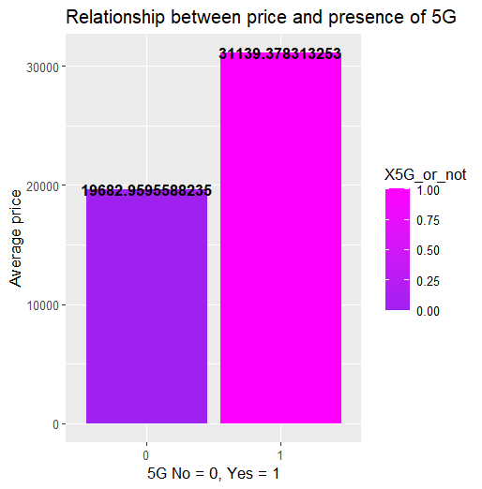

The bar chart compares the average price of the smartphones that have 5G and the average price of the ones that don’t have 5G. The result shows that the smartphones equipped with 5G have and average price (average price with 5G = ₹31,139) significantly higher than the average price of the ones without 5G (average price without 5G = ₹19,683). This suggests that 5G smartphones are typically more expensive, which is expected since the 5G is a relatively new technology and so the models with 5G implemented are usually newer phones with more advanced features and hardware. So, the presence of 5G is a factor that contributes a lot on the rising of the prices of the smartphones in the dataset, even though it’s not the only factor, as we have seen before, that contribute the higher prices.

- RELATIONSHIP BETWEEN THE SCREEN SIZE AND THE PRICE OF THE SMARTPHONES
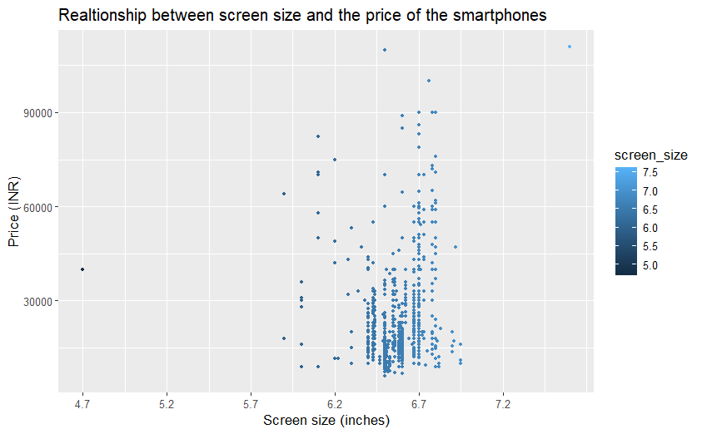

This scatter plot explores the relationship between the screen size and the price of the smartphones. While it might me expected that the price increase as the screen size increases, the plot shows that in our dataset, there is no strong correlation between higher prices and screen size. Most of the smartphones in the dataset fall between the range 6.2 and 6.7 inches and within this range, the prices of these smartphones vary a lot. Some phones with larger screen size are actually less expensive than those with smaller screen size. So, the screen size alone, without other factors, cannot be seen as a reliable predictor of the price, since as we have seen before, there are other factors that play a larger role in determining and increase of the prices of smartphones.
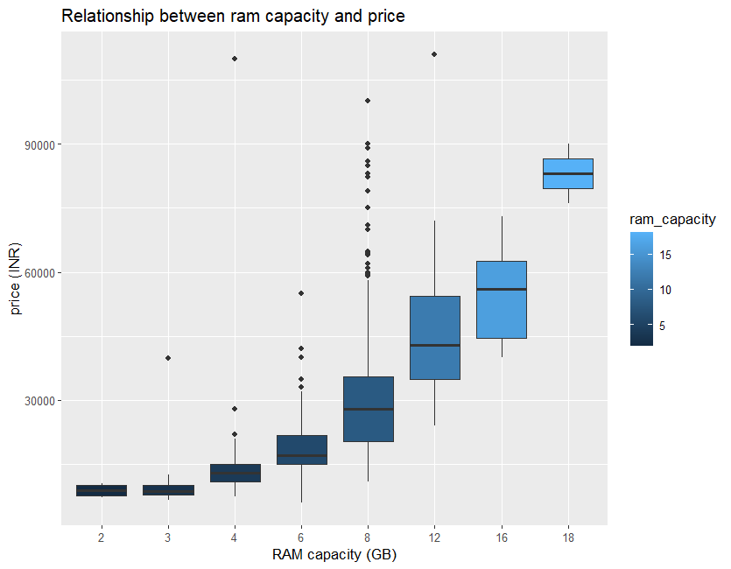
- RELATIONSHIP BETWEEN RAM CAPACITY AND PRICE OF THE SMARTPHONES

The above boxplot illustrates the relationship between the RAM capacity of smartphones and their price. As it can be seen from the plot, there is a clear positive trend, which indicates that as the RAM capacity of the smartphones increase, their average and median price increase as well. The smartphones with RAM capacity between 2 and 4 GB have relatively consistent pricing. On the other hand, higher RAM capacity phones tend to have wider price ranges. The highest RAM capacity in the dataset, as it can be seen, is 18 GB, and as was expected, it corresponds to the smartphones with the highest average and median prices among all the smartphones with lower RAM capacity. So, it can be said that RAM capacity is a factor that contributes significantly to the increase and change of the smartphones price, although it’s not the only factor that contributes to it as seen in the previous points.
Preparing the data before modelling
After completing the Exploratory data analysis, it is important to prepare the data before applying any modelling technique to ensure the quality and the reliability of the results of the analysis. Raw dataset can often contain missing values, duplicate records, irrelevant features that doesn’t contribute to the analysis and can contain variables that present a slightly or highly skewed distribution or even outliers that has to be removed for the clarity of the analysis. All of these can make the predictive models low efficient with a poorer performance. Therefore, this section of the project focus on the cleaning, feature scaling, removal of outliers, selection of numerical variables for the analysis and converting categorical variables when necessary.
- SELECTION AND SCALING OF THE NUMERICAL VARIABLES AND OUTLIER REMOVAL
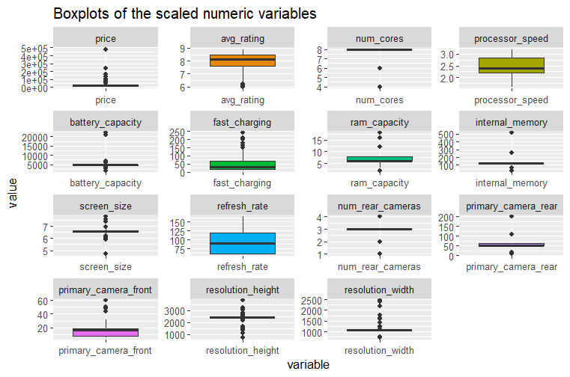
At first, numerical variables were selected and standardized by using the feature scaling. By standardizing them we make sure that each variable has mean = 0 and standard deviation = 1, so that the variables that are measured on different scales like price (in rupees) and RAM capacity (GB), don’t have a disproportionate influence on the models that are going to be applied through the analysis. Following the scaling process, a boxplot representation was made on the numerical variables, in order to catch the presence of outliers within them.

In the boxplot visualization above, some variables like X5G_or_not and extended memory available were removed for plotting purposes, since they are binary variables and do not present any variation among them. However, these variables were retained in the dataset because they may be meaningful in the modelling process.
In this case, the boxplot representation underlined a heavy presence of outliers among the data. Therefore, the next step is to remove the outliers by using a method called Interquartile range (IQR), to improve the reliability of the models that we are going to apply to the dataset afterwards. To do so, a function for outlier removals was created and the following passages and formulas were implemented in it:
- First, the quartiles were identified:
- Q1 (first quartile) = 25th percentile
- Q3 (third quartile) = 75th percentile
- Then, the interquartile range (IQR) was computed:
- IQR = Q3 – Q1
- As the last passage, the upper and lower bound were calculated:
- Lower bound = Q1 – 1.5 * IQR
- Upper bound = Q3 + 1.5 * IQR
At the end, the entire function was applied to the numerical variables, to remove the outliers identified beforehand by using the boxplot visualization.
- ADJUSTING THE SKEWNESS OF THE VARIABLES
After removing the outliers from the numerical variables, the next step was to evaluate the distribution symmetry of these variables by calculating their skewness. Skewness indicates whether a variable is right skewed, left skewed or symmetrically distributed. Before implementing the models, it’s important to correct their skewness, because variables with high values of skewness can negatively affect the results of the analysis, especially for some statistical and machine learning techniques like Principal Component Analysis (PCA) and clustering. Some variables presented NaN values of skewness, which usually indicates that they have zero variance. Such variables do not provide useful information for PCA and clustering, so they were excluded from the modification of the skewness step.
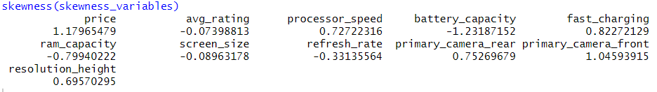
After filtering the variables, their skewness was calculated, and the result were the following:

The most highly skewed variables from the results were:
- Price
- Battery_capacity
- Primary_camera_front
To manage the skewness of these highly skewed variables, a logarithmic transformation was applied. Finally, the variables were standardized using feature scaling so that each of them has mean = 0 and variance = 1. Then, a final check of the skewness was made to make sure that everything worked out perfectly:
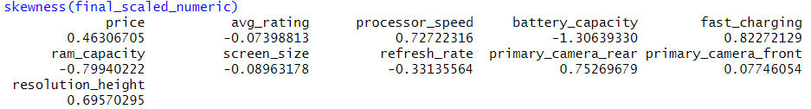
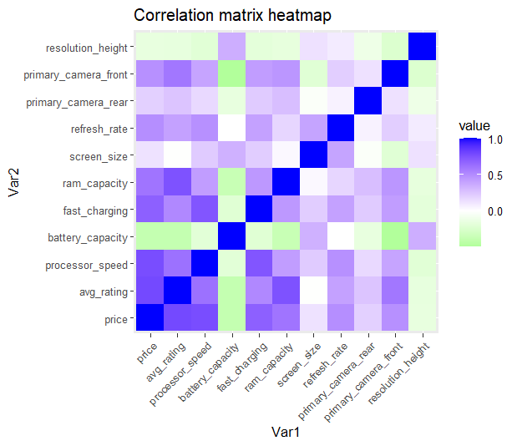
- CORRELATION BETWEEN THE VARIABLES

To explore the relationship among the numerical variables, a correlation matrix was used to show which of the variables have high or low correlation with each other. After the correlation matrix was created, a heatmap was used to visualize it. In the heatmap, “blue” means high correlation, “green” means low or absent correlation and “white” is for moderate correlation of the variables. From the legend of the right, another thing that can be noticed is that +1 indicates a strong positive correlation, while values near zero indicates no linear relationship between the variables. Some of the variables like avg_pricing, processor_speed and fast_charging, as it can be seen from the heatmap have a slightly high correlation with the price variable, while others like battery_capacity and resolution_height have correlation with price near zero. The evaluation of the correlation of the variables is a really important step before PCA or even clustering, because highly correlated variables may affect negatively the results of these statistical learning and machine learning techniques.
Principal Component Analysis (PCA)
Principal component analysis, or PCA, reduces the number of dimensions in large datasets to principal components that retain most of the original information. It does this by transforming potentially correlated variables into a smaller set of variables, called principal components. PCA is commonly used for data preprocessing for use with machine learning algorithms. It can extract the most informative features from large datasets while preserving the most relevant information from the initial dataset. This reduces model complexity as the addition of each new feature negatively impacts model performance, which is also commonly referred to as the “curse of dimensionality”. By projecting a high-dimensional dataset into a smaller feature space, PCA also minimizes, or altogether eliminates, common issues such as multicollinearity and overfitting. Multicollinearity occurs when two or more independent variables are highly correlated with one another, which can be problematic for causal modelling. Overfit models will generalize poorly to new data, diminishing their value altogether. PCA is a commonly used approach within regression analysis, but it is also leveraged for a variety of use cases, such as pattern recognition, signal processing, image processing, and more (source: IBM https://www.ibm.com/think/topics/principal-component-analysis).
So, in this part of the project, after the preparation and the scaling of the numerical variables in the smartphones dataset, Principal Component Analysis (PCA) was applied in order to apply dimensionality reduction on the variables, while maintaining as much of the variance of the dataset as possible. PCA transforms potentially correlated variables (like RAM capacity, battery capacity etc…) into sets of uncorrelated variables, which are called principal components. These components are ordered based on the amount of variance they explain through the dataset. Usually, the first few principal components explain most of the dataset variance, and this allows to apply dimensionality reduction without loosing most of the information for the analysis. The dimensionality reduction process is useful, especially when we have datasets where multiple highly correlated variables are present. Another important characteristic of PCA is that it helps to reduce some other issues like multicollinearity and improves the visualization and the classification of the clusters created. In the analysis made, after applying PCA, the variance explained by each component was analysed to find out how many components should be retained for the next steps of the analysis. The following image represents the result of the principal component analysis:
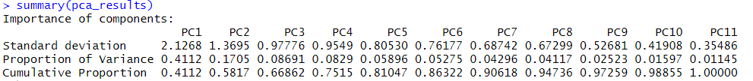

The Principal Components Analysis results show the importance of each principal component by showing how much of the variance in the dataset they explain. We have 3 different values in the output:
- Standard deviation: it represents the variability of the data among each principal component. A higher value of standard deviation in the output means that the corresponding principal component captures more of the variance then other principal components and so it has higher contribution through the dataset structure.
- Proportion of variance: this is the proportion of explained variance explained by each principal components resulting from the principal component analysis.
- Cumulative proportion: it’s the total variance captured by a given number of principal components.
Let’s now analyse the result of the Principal Component Analysis. From the output we can see that:
- PC1 explains 41.12 % of the total variance of the dataset
- PC2 explains 17.05 % of the total variance
- PC3 explains 8.69 % of the total variance
- PC4 explains 8.29 % of the total variance and so on …….
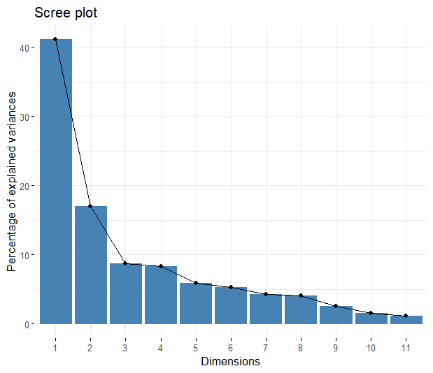
From the results above we can say that most of the variance of the dataset is retained by the first 2 principal components, in fact their cumulative proportion is 58.2 %, which is enough for our analysis. If we add also PC3 then, the cumulative proportion of the explain variance becomes 66.9% which is slightly higher than the one when only PC1 and PC2 where considered. So, the number of optima principal components to retain is between 2 or 3. It can be seen also from the visualization of the Principal Component Analysis results by using a scree plot like the following:

The scree plot above provides a visual representation of the explained variance by each principal component. This visualization confirms that the first two principal components PC1 and PC2 explain most of the variance in the dataset, and after PC3 the percentage of explained variance explained by each additional principal component drops significantly; this is commonly known as the “elbow point”. This clearly indicates that retaining the first two principal components is sufficient for dimensionality reduction, allowing to preserve most of the information of the dataset while reducing the complexity of it.
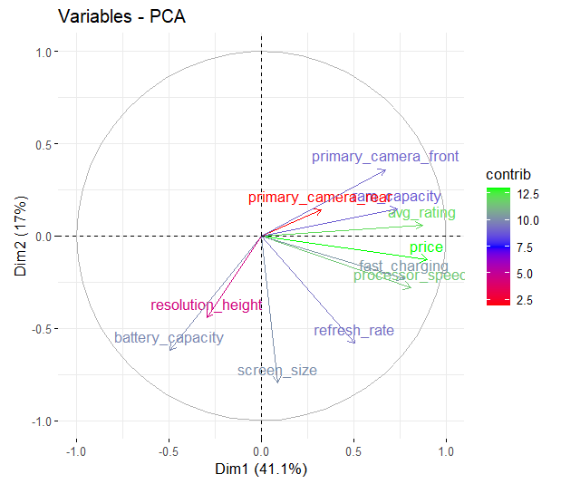
After determining the optimal number of principal components to retain, it is also important to understand how much each variable contributes to the formation of the principal components. To do this, a variable contribution plot can be used, like the following:

This plot is the PCA variable contribution plot, which represents how much each variable contributes to the first two principal components (Dim1 = PC1 and Dim2 = PC2).
- The length of the arrows represents how much the variable contributes to the principal components. A higher length of the arrow means that the corresponding variable contributes more to the principal component than the others.
- The direction of the arrows indicates the correlation between the variables. If the arrows of two variables are pointing at the same direction, this means that they are positively correlated with each other, otherwise, if they point in the opposite direction, it means that they are negatively correlated with each other.
- The legenda on the right part of the plot, shows a gradient of colours which represents the different levels of contribution of the variables on the principal components. For example, if the arrow is green, the contribution of the variable to the principal components is high on the other hand if the arrow is red, the contribution of the variable to the principal components is low. Instead, if the arrow is blue, it means that the contribution is to the principal components is medium, not high or not low.
As we can see from the plot:
- Variables like price, fast_charging and processor_speed contributes most to PC1 because their arrow points mostly horizontally.
- Primary_camera_rear and primary_camere_front point upward toward PC2 and so they contribute more to PC2 rather than PC1
- Battery_capacity, resolution_height contributes to PC1 but in a negative way, and overall, this means that they have a low contribution to the overall principal components.
After evaluating the explained variance and identifying the most important and relevant variables by using different visualization techniques like the scree plot and the variable importance plot, the next step is to select the most informative principal components for the next steps of the analysis. As stated before, the optimal number of principal components to retain is two (since they explain a large portion of the total variance), the first two principal components PC1 and PC2 are the good one for dimensionality reduction. To proceed with dimensionality reduction, the scores for the first two principal components PC1 and PC2 were stored in a new dataset called “pca_data”. This new dataset allows represent the original dataset but with a more simplified structure while maintaining most of the information of the original dataset. This new dataset will be used for the next analysis such as clustering and data visualization, in order to simplify interpretability and computational efficiency do to the smaller dimension of the data.
After the dimensionality reduction, the next step is to determine the optimal number of clusters before applying the K-means clustering algorithm to the dataset. Three methods were used to identify the optimal number of clusters:
- WSS (Within sum of squares) method or “elbow method”:
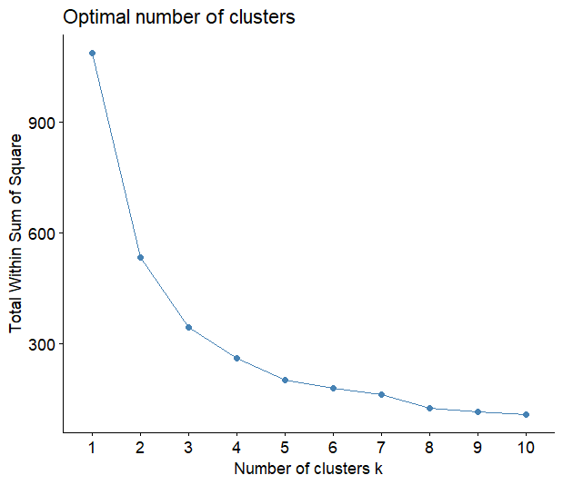

The plot above is the visualization of the results of the “elbow method” used to determine the optimal number of clusters to use in k-means. On the x – axis there is the number k of clusters, and on the y – axis there is the Total Within Sum of Squares. The WSS method measure the compactness of the clusters and as the number of clusters increases the Total Within Sum of Squares value decreases, because adding more clusters leads naturally to better separation. After some point, the improvement rate slows down and the curve starts to flatten. This point is called the “elbow point”. From the plot that has been created, it can be seen that the optimal number of clusters is between k = 2 and k = 3 and this means that adding more clusters will only cause marginal improvements. So, k = 2 and k = 3 are the optimal number of clusters that will be used in the next steps for the k-means clustering analysis.
- Silhouette method:
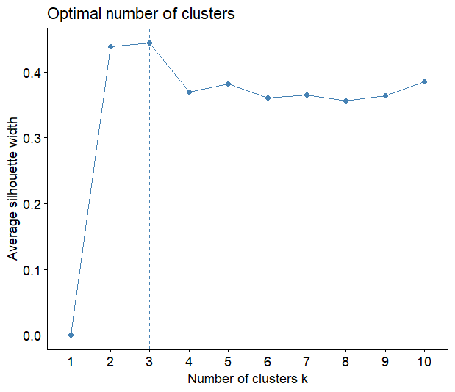

Another method that can be used to identify the optimal number of clusters for K-means clustering is the Silhouette method. The silhouette method measures how well defined a particular cluster is, and how well it is separated from the other clusters. In the plot, the number of clusters is represented along the x – axis, and the average silhouette width is on the y – axis. As it can be seen, the highest average silhouette width is reached in correspondence to k = 3. This means that for the silhouette method, the optimal number of clusters for k – means clustering is k = 3. This confirms the result obtained with the WSS method (k = 2 and k = 3). So, combining these results together it seams that the optimal number of clusters should be k = 3. To ensure that this choice is perfectly correct, a final different method can be applied to verify if the optimal number of clusters for k – means clustering should be k = 3 or k = 2 or both: the gap method.
- Gap method:
The gap statistic method is another technique to estimate the optimal number of clusters for k – means clustering.
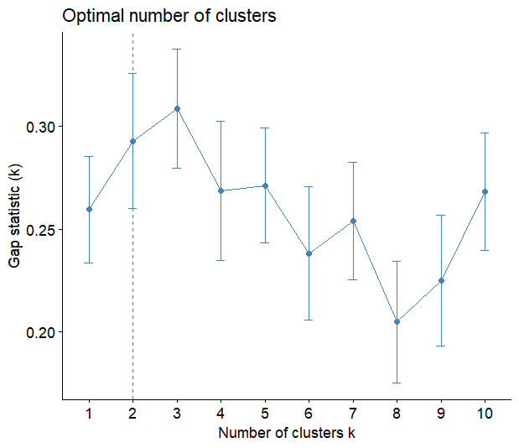

The above plot represents the result of the application of the Gap statistic method. On the x – axis there is the number of k clusters and on the y – axis there is the Gap statistic value corresponding to a value of k clusters. From the plot it can be seen that for the Gap statistic the optimal number of clusters for k – means is k = 2.
Collecting all the result from the three different methods used, the optimal number of clusters for k – means clustering should be k = 2 or/and k =3. Since it’s not clear which of the two k values is the best, it is better to apply k – means clustering to both k = 2 and k =3 and there compare the results to verify which one is better option among them.
K – means clustering
After determining the optimal number of clusters, which is between k = 2 and k = 3, the next step is to apply k-means clustering to the transformed dataset for both cases. Clustering is a widely used unsupervised learning technique for identifying patterns and grouping within the dataset by assigning similar observation to the same group which is called also cluster. So, two cases were examined:
- K-means with k = 2:
First, the k = 2 case was examined. To apply k – means the PCA transformed data (containing the values of only PC1 and PC2 for dimensionality reduction) were selected to conduct the analysis. The k – means algorithm divides the observations of the dataset into a specific number of clusters, in this case since k = 2, then the number of clusters will be 2, by minimizing the total variance within the clusters. To start the algorithm, a random seed (set.seed = 130) was set to ensure the reproducibility of the results. After applying k – means, a plot was created to have a clear visualization of the clusters created during the application of the k – means clustering algorithm when k = 2. The plot is the following:

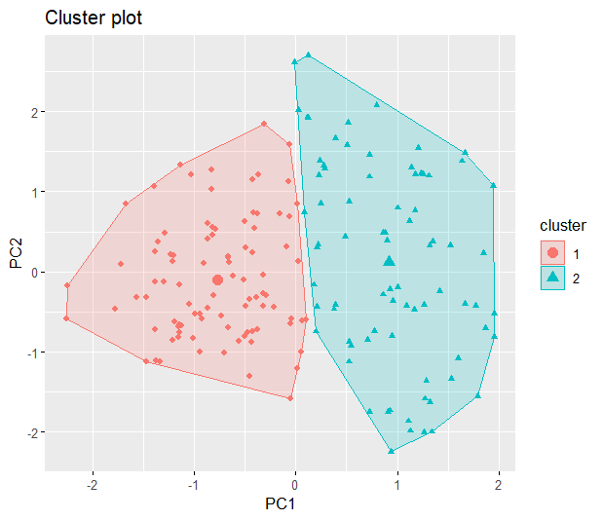

The plot above shows the result of the k – means clustering algorithm when k = 2 on a two-dimensional plane representing PC1 and PC2 which are the first two principal components identified by the previous Principal Component Analysis (PCA). In the plot:
- Each point inside the two regions represents a smartphone in the dataset,
- The different shapes (triangle and circle) and the different colours (blue and red) are used to distinguish better the two clusters,
From the plot it can be seen that the k – means clustering has separated clearly the data into two separate groups (cluster 1 and cluster 2), so k = 2 provides a clear separation of the clusters based on the primary sources of variation captured by the principal components derived beforehand. Given these results, now the case where k = 3 can be analysed to compare it with the result of k = 2 to see which approach is better.
- K – means with k = 3:
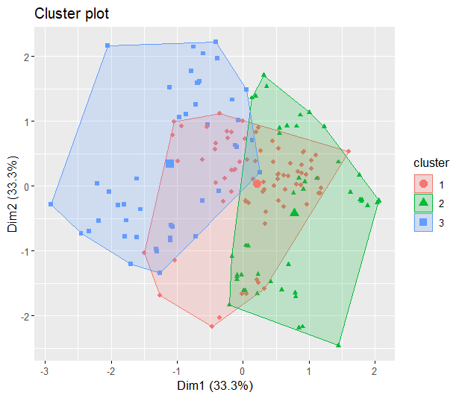

In this case, the first three principal components were selected (PC1, PC2 and PC3) to apply the k – means clustering algorithm for k = 3. Like before, the results of the k – means clustering algorithm was visualized by using a scatter plot. In the plot we have:
- Three distinct clusters identified by different colours and different shapes,
- The clusters overlap and so they have less distinct boundaries,
- The visualization of the three clusters is based on the PC1 and PC2, even though the analysis contains also PC3.
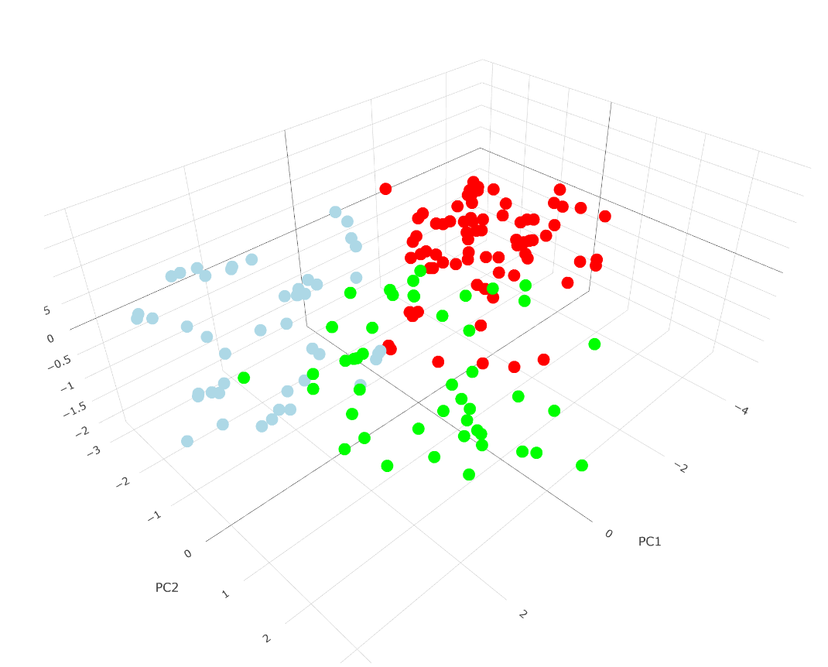
The plot shows three clusters which overlap, and this may indicate that the cluster boundaries are less distinct from each other when increasing the k from k = 2 to k = 3. To show also PC3 in the plot, we can do a 3d plane representation of the clusters like the following:

After applying the k – means algorithm for both k = 2 and k = 3, to evaluate which of them is the most effective, the silhouette method was applied. The silhouette score indicates how compact and well defined the clusters are; so, if the silhouette score is high, then the clusters are well defined with well defined boundaries within them. First, the silhouette method was applied to k = 2 and the result of the silhouette score was the following:
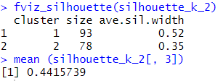

The resulting plot for this results it:
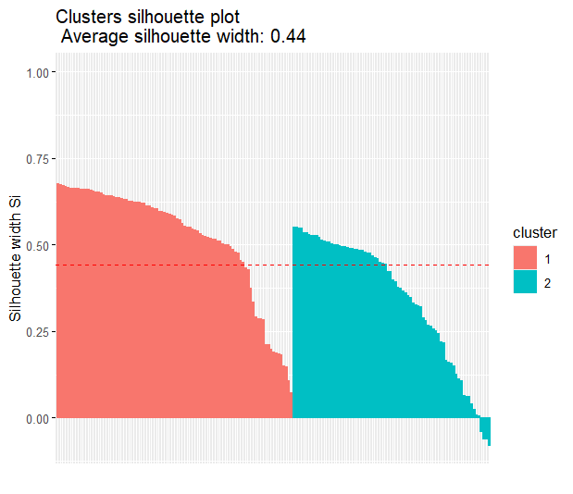

So, the silhouette score for k = 2 is 0,44. Now let’s analyse also the silhouette score for k = 3.
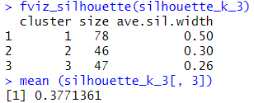

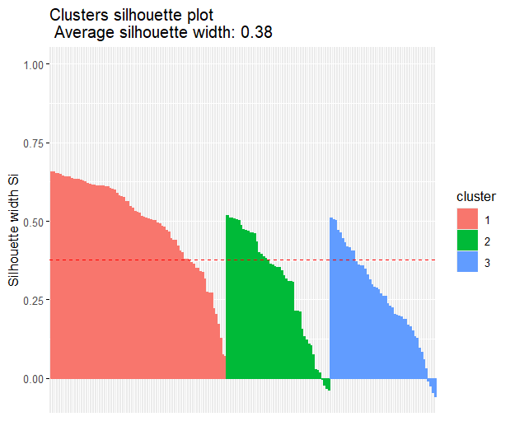
And the resulting plot is the following:

In this case, the resulting silhouette score is 0.38. So, comparing the results, since a higher silhouette score means more defined clusters, k = 2 should be the optimal number of clusters because 0,44 > 0,38. Therefore, k = 2 is preferred for the k – means clustering in this case.
Hierarchical clustering
Then, hierarchical clustering was applied. Hierarchical clustering is an unsupervised learning technique which creates a hierarchy of clusters without the need of a pre – defined number of clusters (like it happens in k – means clustering). All the 5-linkage methods were applied, first to k = 2:
- Single linkage
- Average linkage
- Complete linkage
- Centroid
- Ward linkage
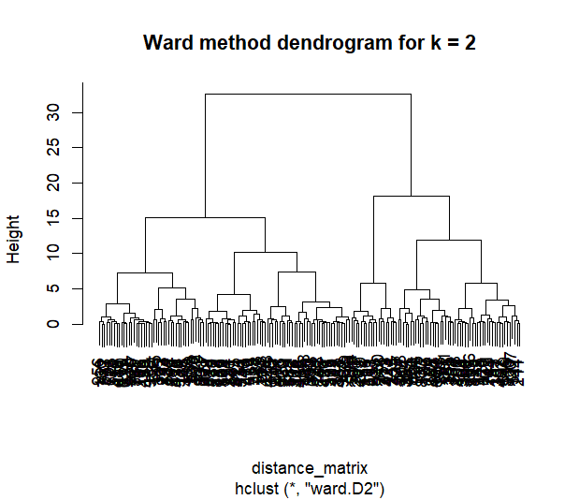
The one that provided the clearest dendrogram was the Ward linkage, and the dendrogram was the following:

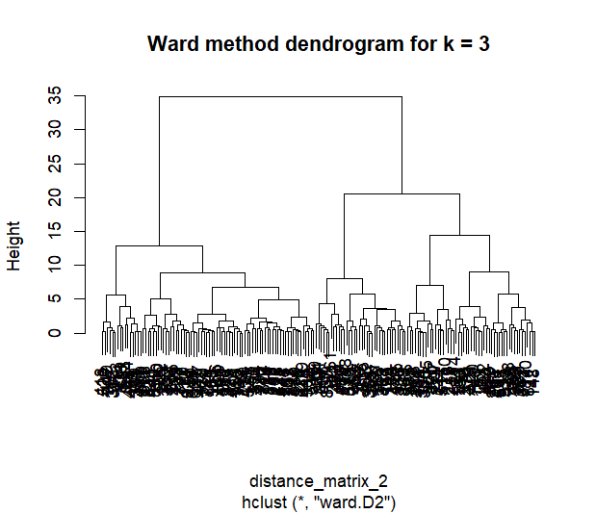
Then, since the best one was the Ward linkage, it was applied also for k = 3:

Supervised learning
Supervised learning, unlike unsupervised learning, uses labelled data to train the algorithm allowing it to learn patterns and relationships between input features and known outputs in order to make accurate predictions on new data. In this part of the project, some supervised learning techniques were used, such as Support Vector Machines (SVM), Random Forest, trees, and logistic regression to determine which of them performs best on the datasets chosen for predictive tasks.
Dataset
For this part of the project the Breast cancer dataset from Kaggle was used. It contains information and measurements about cell nuclei from breast mass tissues samples. The objective is to find out throughout these characteristics if the cancer is malignant or benign. In the dataset the labels are M = malignant and B = benign. The variables contained in the dataset are the following:
- Id: is the identification number of each patient contained in the dataset.
- Diagnosis: it’s the target variable and it is equal to M and B depending on the fact that the cancer is malignant or not.
- Radius_mean, radius_se, radius_worst: average, variation and maximum distance from the nucleus centre and its perimeter.
- Perimeter_mean, perimeter_se, perimeter_worst: it’s the length of the tumour boundary.
- Area_mean, area_se, area_worst: it’s the area of the tumour within the boundary.
- Texture_mean, texture_se, texture_worst: it is how rough the cell of the tumour looks in the images taken.
- Smoothness_mean, smoothness_se, smoothness_worst: it measures the smoothness of the boundary of the tumour, so how much the radius length vary throughout all the area of the tumour.
- Compactness_mean, compactness_se, compactness_worst: measure the compactness of the cell shape of the tumour.
- Concavity_mean, concavity_se, concavity_worst: severity of concave portions of the contour.
- Concave_points_mean, concave_points_se, concave_points_worst: number of concave points in the contour.
- Symmetry_mean, symmetry_se, symmetry_worst: it measures the symmetry of the cell shape.
- Fractal_dimension_mean, fractal_dimension_se, fractal_dimension_worst: it’s the fractal dimension of the boundary.
The aim of this part of the project is to use different supervised machine learning techniques in order to predict if the cancer of the patient is malignant or benign according to the features and measurements that are present in the dataset.
Exploratory data analysis (EDA)
Before modelling, it is important to clean the data and to perform Exploratory Data Analysis (EDA) in order to identify beforehand patterns and relationships between the variables, and in order to be sure that the data is prepared for modelling. As in the previous unsupervised learning part of the project these steps are important to improve model interpretability and performance. First, the dataset was checked for missing values and duplicates:
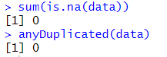
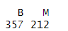
The results of this check confirmed that there are no duplicated values or null values in the dataset, so, no removal and modification of records was needed. Following this passage a first visualization and exploration of the target variable “diagnosis” was done in order to understand the class distribution within the dataset. Using the “table” command, the frequency table revealed that:

- 357 patients were diagnosed with a benign form of breast cancer.
- 212 patients were diagnosed with a malignant form of breast cancer.
This target variable, which originally contained categorical values (M = malignant and B = benign) was transformed into a binary variable where M was replaced with 1 and B was replaced with 0, meaning that when the variable is equal to 1 then the patient has been diagnosed with a malignant form of cancer and if the variable is equal to 0 the cancer is benign. This change was made because most of the supervised machine learning algorithms performs better with numerical variables rather than with categorical variables for classification tasks.
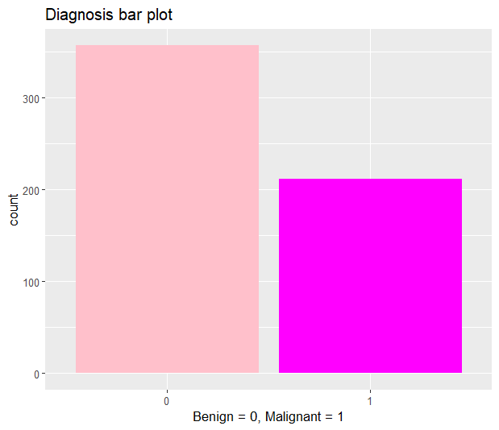

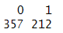

Then, histograms and density plots for the numerical variables were computed in order to visualize the distribution of the variables within the dataset and also their skewness:
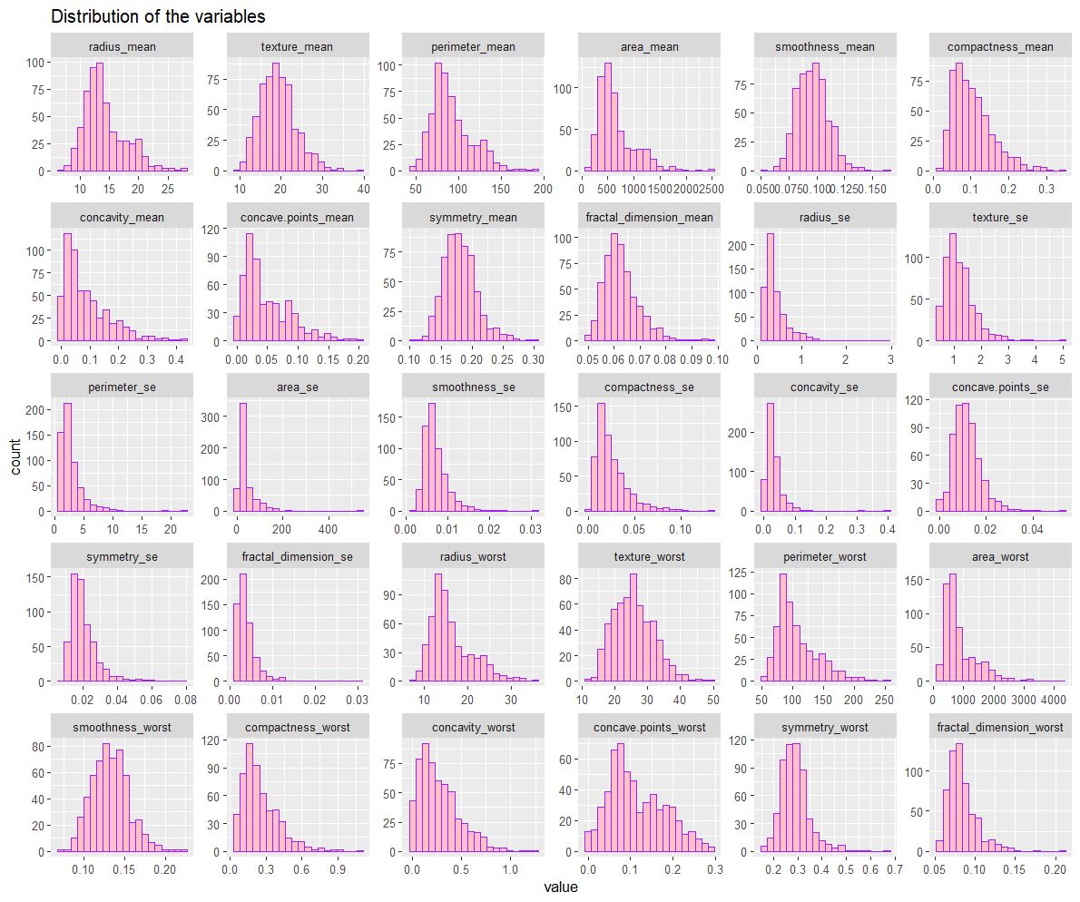

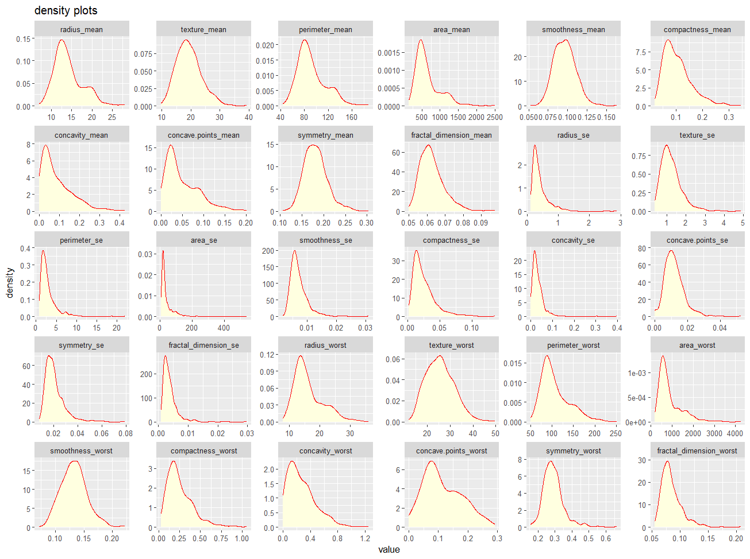

A lot of the variables in the dataset, present a highly skewed distribution and, more precisely, they are right – skewed. Since high skewed variables can negatively affect the performance of the learning algorithms, this issue will be addressed later in the processing phase using normalization techniques.
To understand better the relationship between some cancer features and the diagnosis (malignant or benign) several visualizations were created through box plots, scatter plots and histograms, allowing a comparison of the distribution of some features through the diagnosis classes. Each variable was individually analysed in comparison to the target variable “diagnosis” to see the initial contribution of these variables on the actual diagnosis.
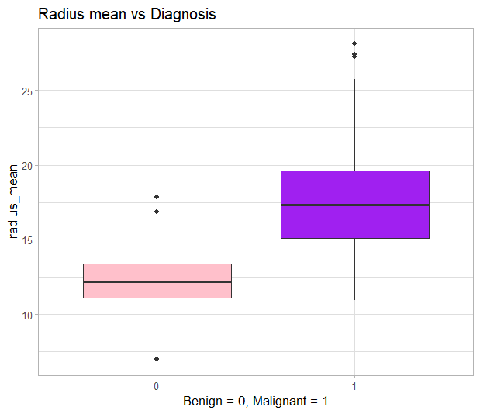
- RELATIONSHIP BETWEEN RADIUS MEAN AND DIAGNOSIS
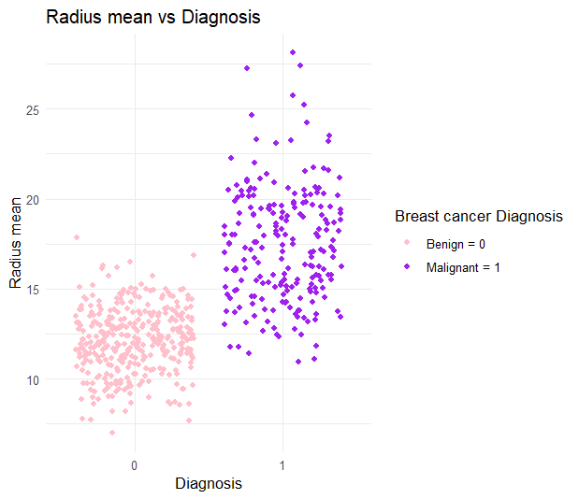

The visualization of this relationship revealed that there is a strong separation between the two diagnosis classes; in fact, malignant cases consistently present higher values of radius mean compared to the ones that are diagnosed as benign. This suggests that tumours with larger radius mean measurements tend to be diagnosed as malignant more frequently than those with smaller radius mean. So, radius mean can be considered as one of the factors that contributes most to a malignant diagnosis.
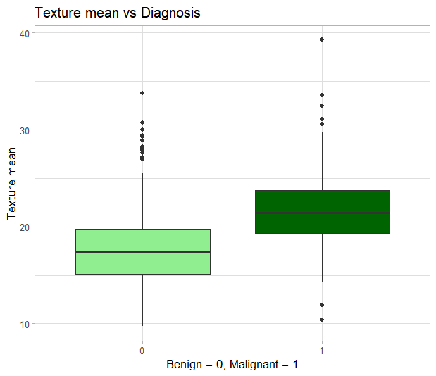
- RELATIONSHIP BETWEEN TEXTURE MEAN AND DIAGNOSIS
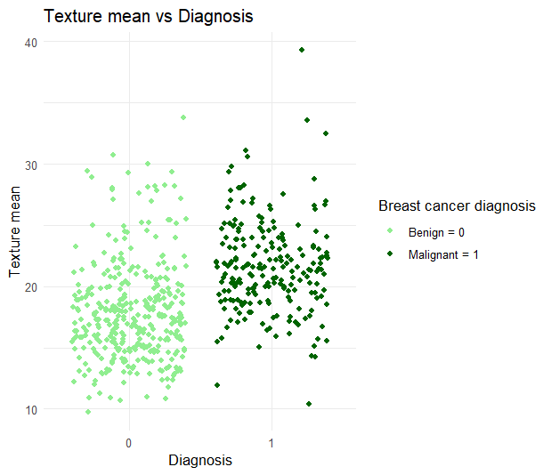

Also, texture mean showed higher media values for malignant tumours. So, higher texture mean values can lead to a malignant diagnosis. Compared to the radius mean, texture mean as a smaller separation between the two classes, making it a less useful predictor than the radius mean.
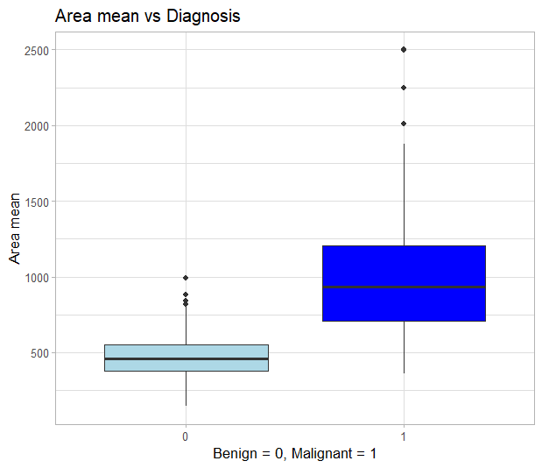
- RELATIONSHIP BETWEEN AREA MEAN AND DIAGNOSIS
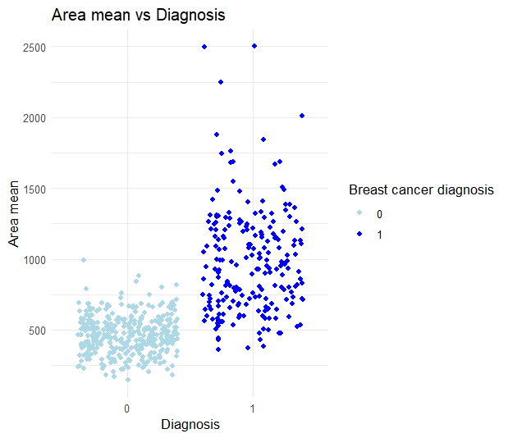

From the boxplot it can be seen that the median value of the area mean is significantly higher for patients diagnosed with a malignant form of tumour in respect to the median value of the ones diagnosed with a benign form. This suggests that malignant tumours tend to have larger area mean and so the area mean can be considered as a strong predictor for the likelihood of having a malignant form of cancer. The scatter plot further supports this statement, because it shows that area mean values are more densely populated in the malignant class, on the other hand patients which present a lower area mean are mostly diagnosed with a benign form of tumour.
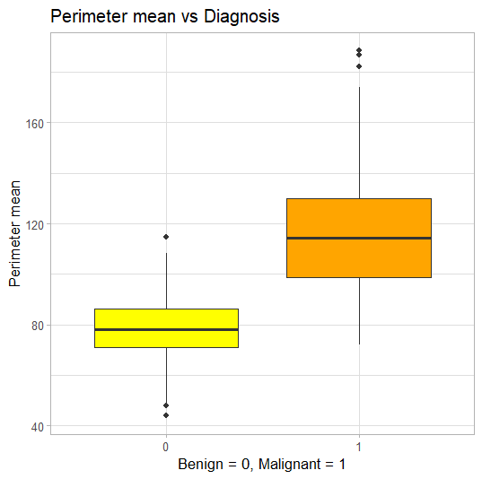
- RELATIONSHIP BETWEEN PERIMETER MEAN AND DIAGNOSIS
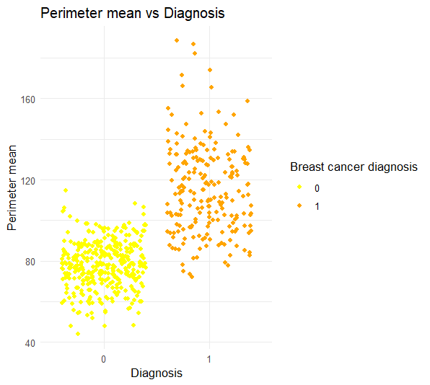

Another variable that seems to play an important role in the diagnosis of a malignant tumour is the perimeter mean. Also, for this variable in the boxplot, the median value of the perimeter mean is significantly higher for patients diagnoses with a malignant tumour in respect to those who have been diagnosed with a benign form. The scatterplot visualization confirms this conclusion by showing a more densely populated area around higher values of perimeter mean for those who have been diagnosed with a malignant form of cancer. So, also the perimeter mean can be considered a strong predictor for the cancer diagnosis.
- RELATIONSHIP BETWEEN CONCAVITY MEAN AND DIAGNOSIS
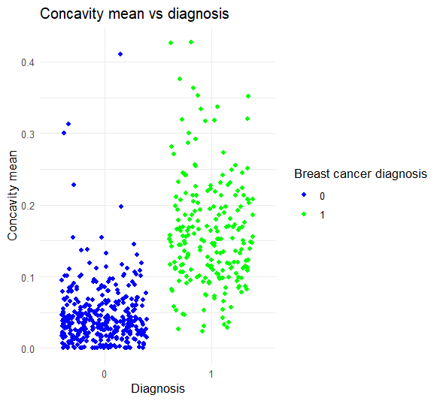
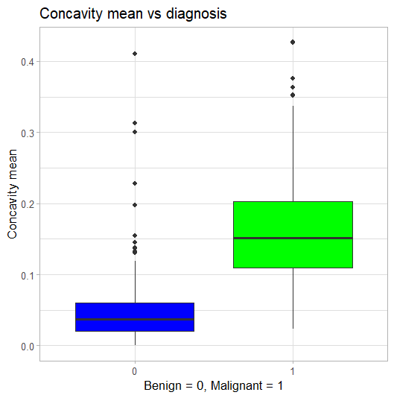

As the boxplot and the scatter plot have the same characteristics as the previous variable’s plots, then also concavity mean can be seen as a strong predictor for the cancer diagnosis in the patients.
- RELATIONSHIP BETWEEN SYMMETRY AND DIAGNOSIS
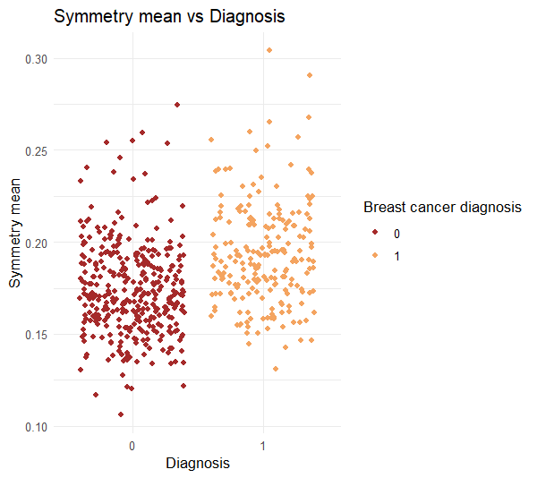
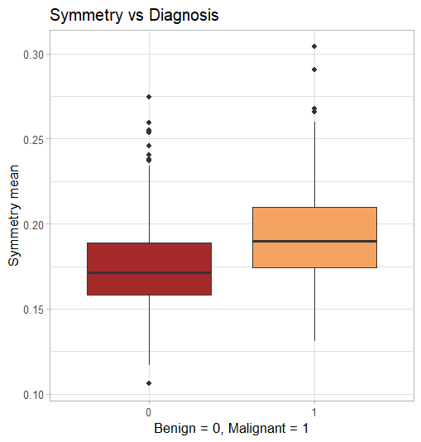

In this case, the difference of the median values of symmetry mean is not to much between patients diagnosed with malignant tumours and benign ones. This can be seen also from the scatter plot where the distribution of the population is mostly the same for the two classes. So, there is a slight difference between the two classes that suggests that a higher symmetry mean can lead to a greater likelihood for the patient to be diagnosed with a malignant tumour, but this does not make the symmetry mean a strong predictor as other variables considered before like radius mean and perimeter mean. On the other hand, it can be still important to consider it because it may have a strong effect on the diagnosis if associated with other variables, and so it can still give a contribution to the analysis.
- RELATIONSHIP BETWEEN FRACTAL DIMENSION MEAN AND DIAGNOSIS
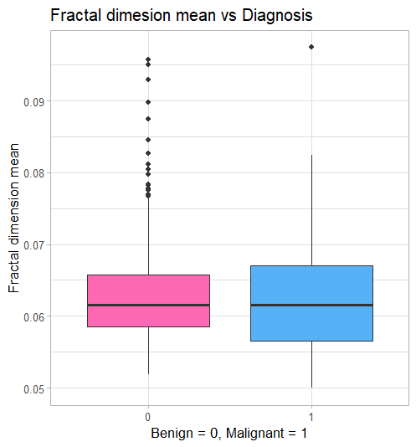
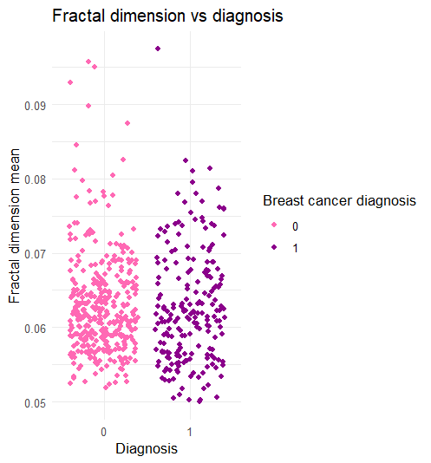

As in the previous case, also here the difference between the two median values of fractal dimension mean in the boxplot and the distribution of the population within the two classes in the scatter plot show only a slight difference (they are mostly identical in this case). This suggests that the fractal dimension mean variables alone cannot be a strong predictor for the cancer diagnosis, but its role shouldn’t be dismissed because it could contribute to our analysis by giving information in association with other variables.
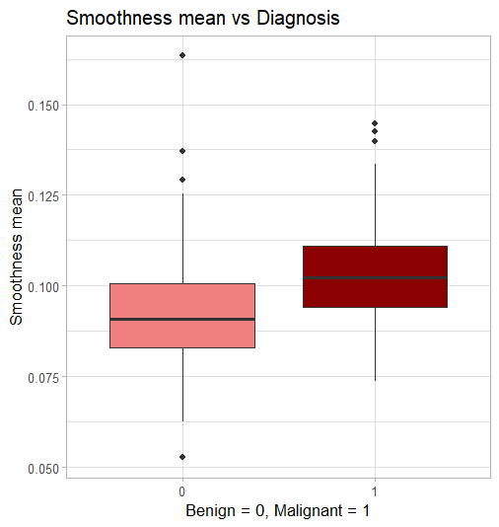
- RELATIONSHIP BETWEEN SMOOTHNESS MEAN AND DIAGNOSIS
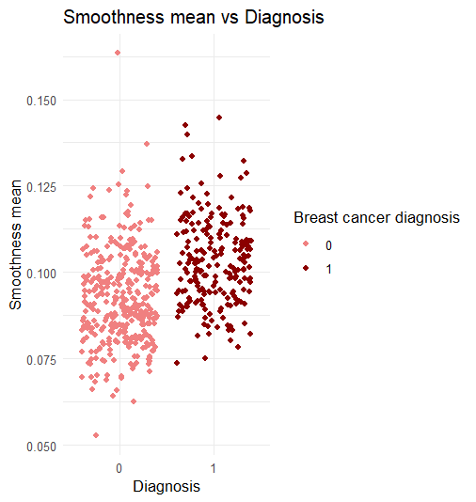

Also, for the variable smoothness mean both the boxplot and the scatter plot don’t show a high difference between the effect of smoothness mean withing the two classes of diagnosis. This means that also smoothness mean is not a standalone strong predictor, but it may still be useful in combination with other variables for the sake of the analysis.
- RELATIONSHIP BETWEEN COMPACTNESS MEAN AND DIAGNOSIS
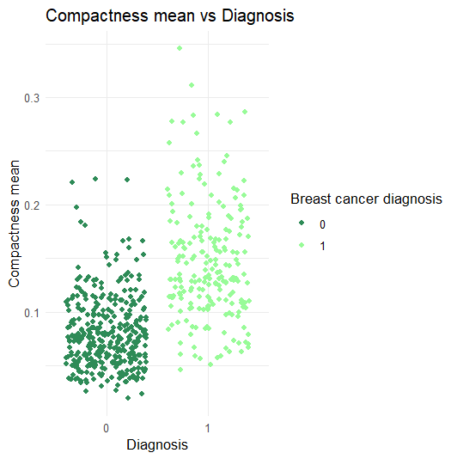
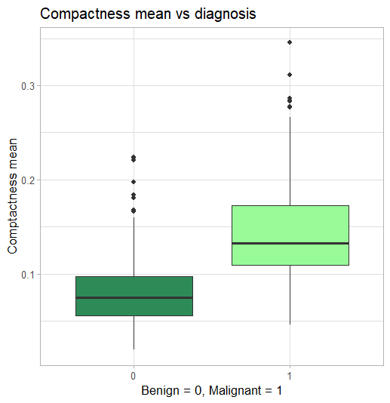

Another important variable considered in the analysis is the compactness mean. This time, the boxplot shows a higher difference between the median value of compactness mean for malignant diagnosis and benign diagnosis. Furthermore, the scatterplot confirms this conclusion by showing a higher density population within the area of the malignant class in respect to the area of the benign class. So, along with variables like radius mean and perimeter mean, compactness mean can be considered a strong predictor for the diagnosis, contributed greatly to the analysis also like a standalone variable.
Preparing the data before modelling
Before applying supervised learning models to the dataset, it is important to prepare and clean the data appropriately. Like in the unsupervised part of the project, this step consists in removing outliers, checking for duplicates, selecting numerical variables, scale the variables, checking and adjusting the skewness of the variables and so on.
First, it is important to check for the skewness of the numerical variables to determine the presence of asymmetry, which can affect the performance and interpretation of the machine learning models. Since in the datasets considered, all the variables are numeric, we considered them also except for the diagnosis variable, which is a binary variable and the target, thus its skewness its not meaningful. By computing the skewness for all the numerical features, it can be seen that most of them present right – skewed distributions. To reduce the skewness of the variables a log transformation was applied. Checking again the skewness after the logarithmic transformation, most of the variables improved significantly their skewness values except for:
- Concavity_mean
- Concave.points_mean
- Fractal_dimesion_se
These variables are still right – skewed and so, to further reduce their skewness, also a sqrt transformation was applied to them. This second reduction was successful, and their skewness values were brought below 1. This step is important because most of the machine learning models performs better when the variables are normally distributed.
The next step was to scale the numerical features in the dataset in order to allow for an improvement in performance for the supervised machine learning algorithm that are going to be used later. Since in the dataset all the variables are of type numeric the standard scaling was applied to all the variables, except for two of them:
- ID: this variable was removed previously from the dataset because it doesn’t give any contribution to the analysis since its only an identifier for the patients and does not have any meaning for the diagnosis of the breast cancer.
- Diagnosis: since this is the target variable that will be used for the classification task for the supervised machine learning algorithms, scaling was not applied to it in order to preserve its binary nature, because altering it can lead to a negative effect on the performance and interpretation of the models that are going to be applied to the dataset and also can lead to incorrect predictions.
After the scaling of the variables, the next step was to check for the presence of outliers, which are data points that deviate significantly from most of the data that can have a negative impact on the supervised machine learning models performance. To identify visually the presence of outliers in the dataset, boxplots were used:
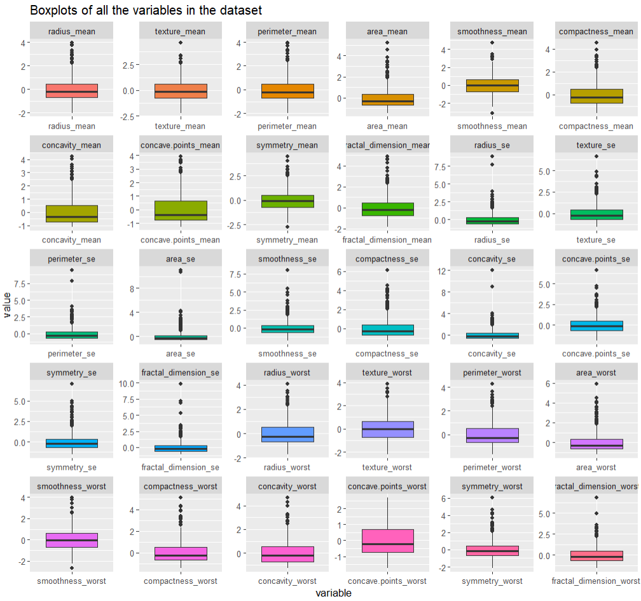

The boxplots underlined a great presence of outliers within the dataset (the outliers in the image are the black point that appear above and below the area of the “box”). This issue maybe handled before modelling. As it was done for the unsupervised learning process, the outliers were removed by using the Interquartile range (IQR) method.
After the cleaning process of the data a correlation matrix was computed in order to evaluate the relationships between the numerical features in the dataset. To see more clearly these relationships, a correlation heatmap was computed were:
- Lighter colours indicate weaker correlation between the variables
- Darker shades indicate stronger correlations
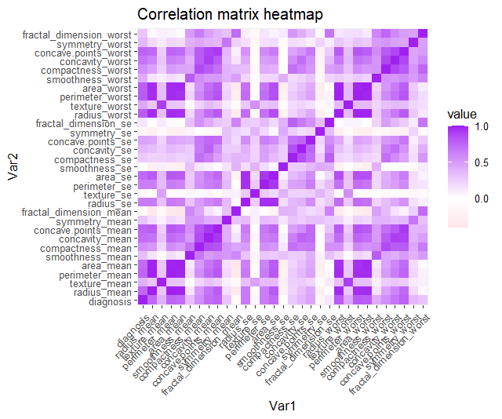
- The diagonal in the centre of the heatmap shows perfect correlation between each variable and itself (value = 1)

This information is important for feature selection because redundant variables may have a negative effect on the performance of some algorithms. It is best practice to identify and to remove the highly correlated variable from the dataset to improve the performance of the algorithms also to avoid multicollinearity. These were the highly correlated variables that were removed:
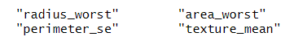

Now, the data were completely cleaned and prepared in order to begin with the modelling part of the supervised learning part of the project. The next step will be applying supervised learning algorithms to predict the diagnosis of breast cancer of the patients in the dataset and to find out which of the models is the most accurate and the best suitable for this classification task.
Supervised learning models for predicting diagnosis outcomes
To assess the performance of the different supervised models that are going to be used in our analysis on the diagnosis of breast cancer, the dataset was at first divided into a train and a test set where 80% of the data were used for the training set and the remaining 20% for the test set. This step is important because by this we can see how well an algorithm generalize to unseen data, helping to prevent both overfitting and underfitting.
Before beginning with modelling, a cross-validation strategy was applied. So, the data were divided into 20 equally sized folds and in each iteration during the cross validation one fold was used for validation while the other 19 folds are used for training. Each of the folds serves as a validation set ones during each repetition of the process (20 repetitions were set). This method helps to reduce the risk of overfitting and helps also to have a more precise estimate of the accuracy of the models. After this step the modelling phase began.
- REGULARIZED LOGISTIC REGRESSION WITH GLMNET
The first model applied was logistic regression. At the beginning, the regular form of logistic regression with “glm” was used, but this type of regression in this case caused some convergence warnings and unstable estimates of the coefficients due to multicollinearity which is a common issue with logistic regression when some features in the dataset are redundant or highly correlated. So, to address this issue, the regularized version of logistic regression with “glmnet” was used instead of the regular logistic regression model. This choice was made because the regularized logistic regression contains both Lasso and Ridge regularization which help to reduce overfitting and to improve the performance stability of the model when there is the presence of multicollinearity.
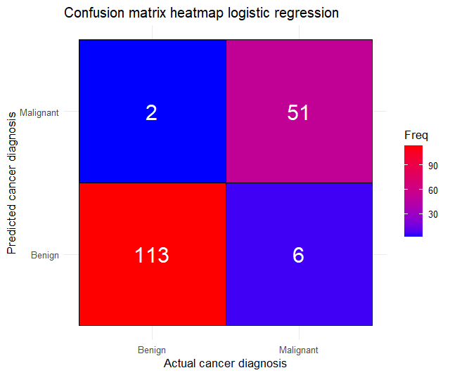
Then, the model was trained by using the training set applying the cross-validation strategy introduce before. After the training of the model probabilities and predictions were computed by using this time the data of the test set. To evaluate the performance of the model implemented after training it, different methods where used. First, a confusion matrix was created to find out how well the model correctly classifies the diagnosis between “malignant” and “benign”. This correlation matrix was then represented visually by using the following heatmap:

These heatmap represent the comparison between the actual and the predicted class of the breast cancer diagnosis for the regularized logistic regression model. On the x – axis there is the actual cancer diagnosis while on the y – axis there is the predicted cancer diagnosis and the colours in the legend on the right of the heatmap represent the frequency of the prediction where red means high frequency and blue instead means low frequency. From this heatmap it can be seen that the type of logistic regression that was used, performed quite well in identifying the two classes, in fact we have:
- True positives: 51 cases where malignant diagnosis was correctly predicted as malignant
- True negatives: 113 cases where benign diagnosis was correctly predicted as benign
- False positives: 2 cases where benign diagnosis was incorrectly predicted as malignant
- False negatives: 6 cases where the malignant diagnosis was incorrectly predicted as benign
So, overall, the performance of the model is quite good, even thought in prediction models in the medical field even one wrongly predicted class can cause several issues for the patients itself. Then the accuracy of the model was computed on the test set revealing and accuracy of 0.9535 so 95.35%. Then, to further evaluate the performance of the model, the ROC curve and the AUC were used:
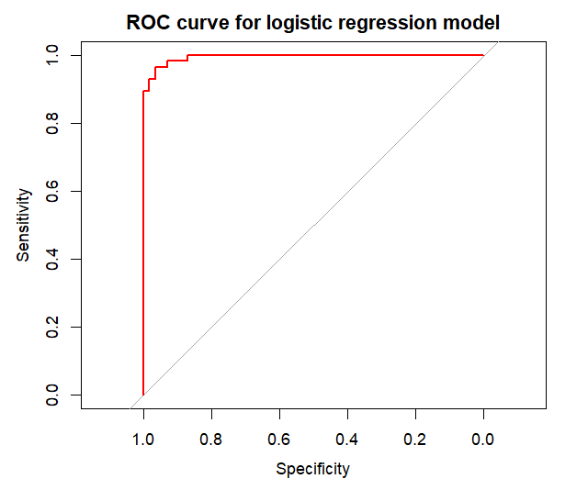

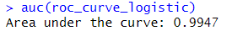

The ROC curve represents the trade of between the true positive rate and the false negative rate that are respectively the sensitivity on the y – axis and the specificity on the x – axis and the value of the AUC (area under the curve) of this curve resulted in 0.9947. Again, this remarks the fact that the regularized logistic regression has a really strong performance in distinguishing between malignant and benign cancer diagnosis.
The same thing was made also on the train set in order to detect the presence of overfitting or underfitting in the model performance. The ROC, AUC and the accuracy for the model performance by using the train set were the following:
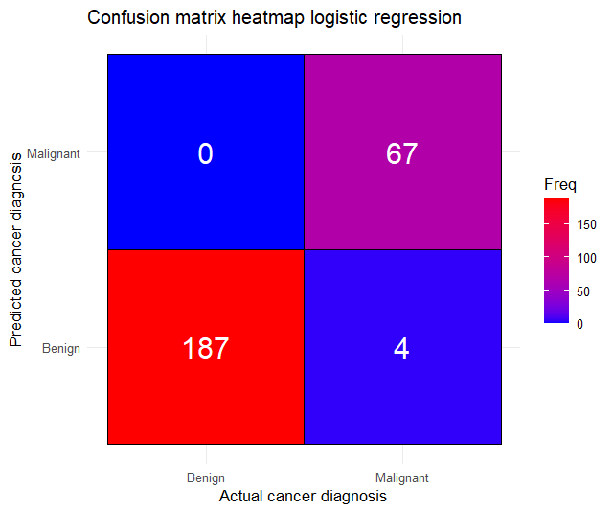
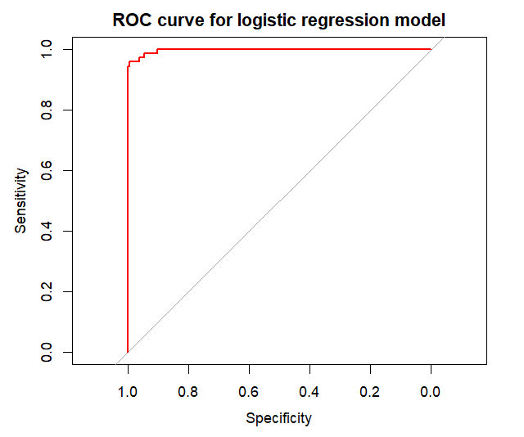

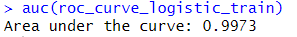

In this case the accuracy was around 0.9845 so 98.45% and the AUC was 0.9973. Comparing these values to the ones obtained using the test set, we can conclude that there is a very slight overfitting or even absent overfitting in the model performance as their accuracy values are quite similar to each other and both sets underline a high performance for the regularized logistic regression in predicting the breast cancer diagnosis.
- DECISION TREE
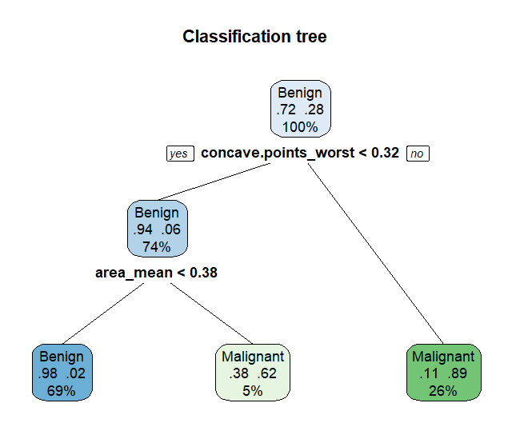
The second model that was applied was the decision tree with the function “rpart”. The result after plotting it was the following:

The above plot represents the classification tree trained in the train set and its structure reflects the one of the decision processes used by the algorithm. As we can see, the tree starts with the root node, which considers the variable “concave.points_worst”. This feature according to this plot, it’s probably the most relevant and the most informative for making the classification decisions about the breast cancer diagnosis. In this root node the tree specified that for concave.points_worst < 0.32 most of the cases were classified as benign (74%) and the remaining one were classified as malignant tumours (26%). Then if the diagnosis classification were “benign” the tree continued with the split by choosing the variable “area_mean”. If area_mean was less than 0.38, then the tree classified the 69% of the cases as benign and above that value, the remaining ones were classified as malignant (5%).
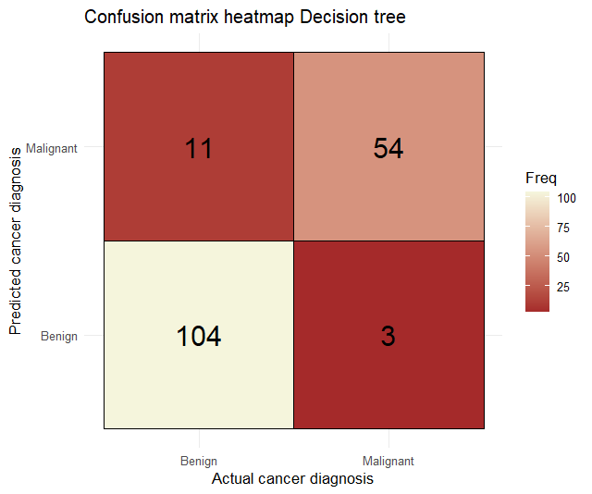
Like in the previous model, a confusion matrix was created to evaluate how well the decision tree classifies the diagnosis between the two classes of diagnosis. In this case:

- True positives: 54 cases where malignant diagnosis was correctly predicted as malignant
- True negatives: 104 cases where benign diagnosis was correctly predicted as benign
- False positives: 11 cases where benign diagnosis was incorrectly predicted as malignant
- False negatives: 3 cases where the malignant diagnosis was incorrectly predicted as benign
So, like logistic regression, the decision tree has a good performance on classifying the diagnosis between the two classes malignant and benign. The accuracy of this models resulted in 0.9186 (91.86%) and the ROC and the AUC for the test set were the following:
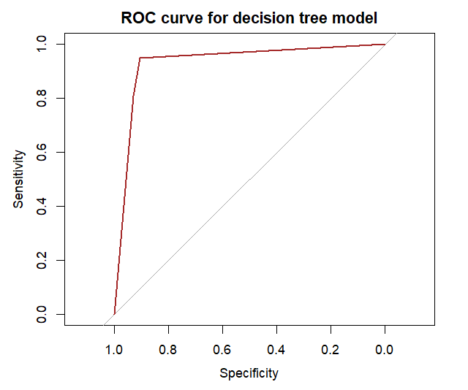

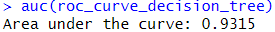

The ROC curve underlines again that the model performance is quite good and the AUC of 0.9315 is good as well because it indicates that there is a 93.15% chance that the model will predict the actual classes correctly. So, despite some misclassification, the model as a great capability to distinguish between malignant tumours and benign ones.
The same thing was made also for the train set as follows:
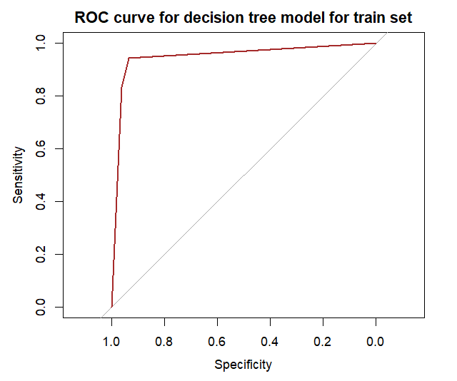
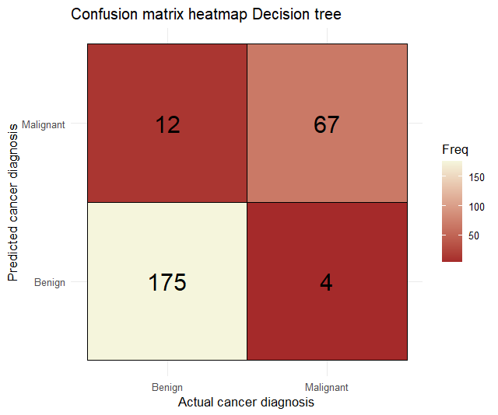

This time, the accuracy is equal to 0.938 so 93.8% (which is higher than the value computed for the test set), and the AUC is 0.9487 suggesting, in comparison to the values of the test set, a slight presence of overfitting.
- RANDOM FOREST
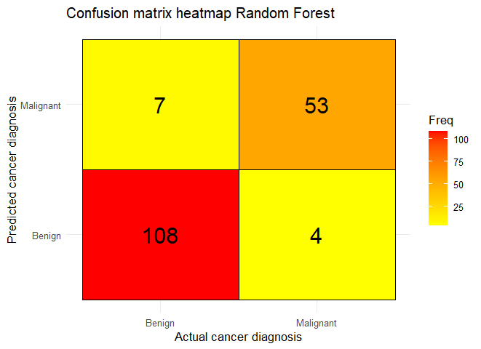
Another algorithm that was used for this classification task was Random Forest. Random Forest is an algorithm that construct multiple decision trees and then aggregates the output of each tree to have a more accurate prediction. First, as it was done also in the previous models’ evaluations, a confusion matrix with its heatmap was computed to observe how well the algorithm classifies the diagnosis correctly or incorrectly. In this case the results were the following:

Where:
- True positives: 53 cases where malignant diagnosis was correctly predicted as malignant
- True negatives: 106 cases where benign diagnosis was correctly predicted as benign
- False positives: 7 cases where benign diagnosis was incorrectly predicted as malignant
- False negatives: 4 cases where the malignant diagnosis was incorrectly predicted as benign
Even though there are some wrong predictions, the model still has a good performance, predicting most of the diagnosis classes correctly. The accuracy of this model confirms the previous statement again underlying that the model reached an accuracy of 93.6% on the test set. This is furtherly expressed by the ROC curve and its value of AUC in the following visualization:
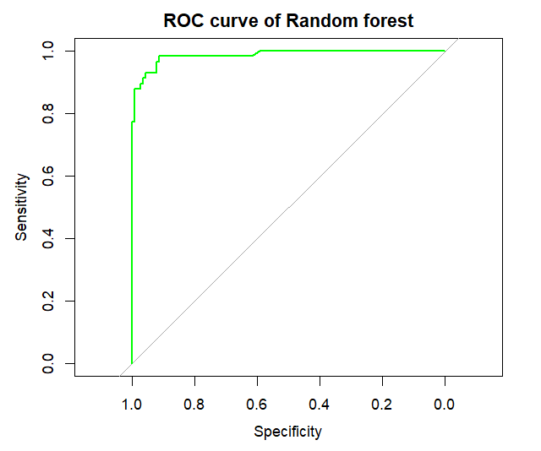

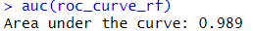

Again, to evaluate the presence of overfitting or underfitting the same procedures were done also on the train set:
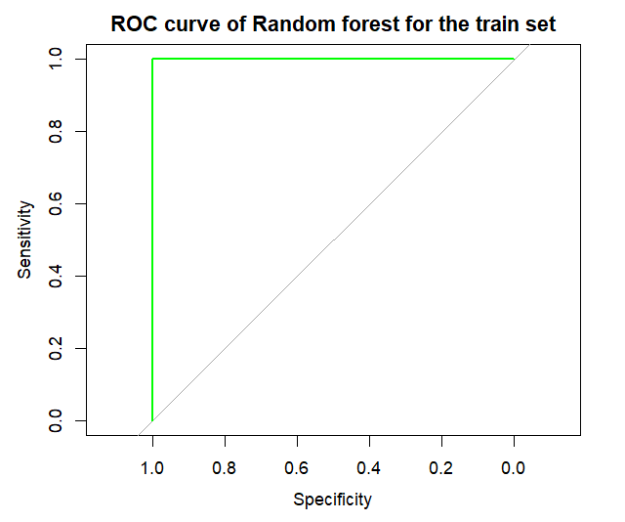
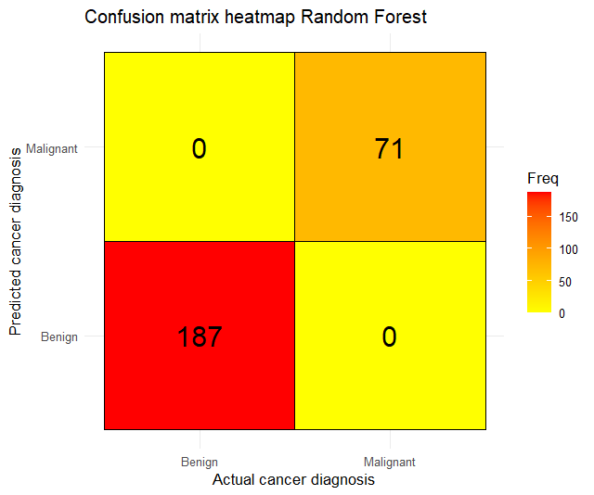

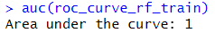

Seeing the heatmap and the ROC curve, there is some overfitting in the Random Forest model as it can be seen from the training set performance. However, the performance on the test set remains strong with values of AUC and accuracy not too much distant from the values of the training set. So even though there is some overfitting, the performance of the model in the prediction of the breast cancer diagnosis is still good and this underlines that the model generalizes well to unseen data.
Another thing we can do is to compute the variable importance plot to see the reasoning behind it and to find out which of the variables were considered the most important within the dataset.
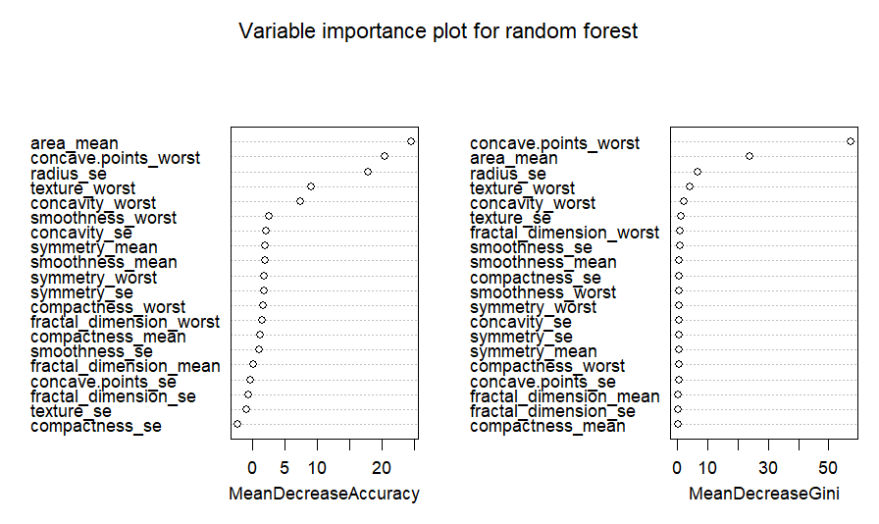

The model identified as the most important variables area_mean and concave.points_worst; this according to the model are the features that contributed the most to the predictions of the Random Forest algorithm and so they hold extremely high discriminate power between malignant and benign cancer diagnosis.
- SUPPORT VECTOR MACHINES (SVM)
The last method used for this analysis was the Support Vector Machines (SVM) algorithm. In the code, to understand which of the models was the greatest one, support vector machines were applied with radial basis function, polynomial basis function and linear basis function. The most performative one was the one with the radial basis function and so only this one is going to be analysed in this section. The results of this type of support vector machines on the predictions were the following ones:
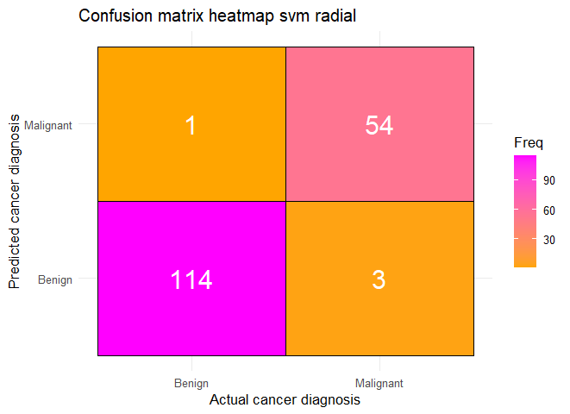
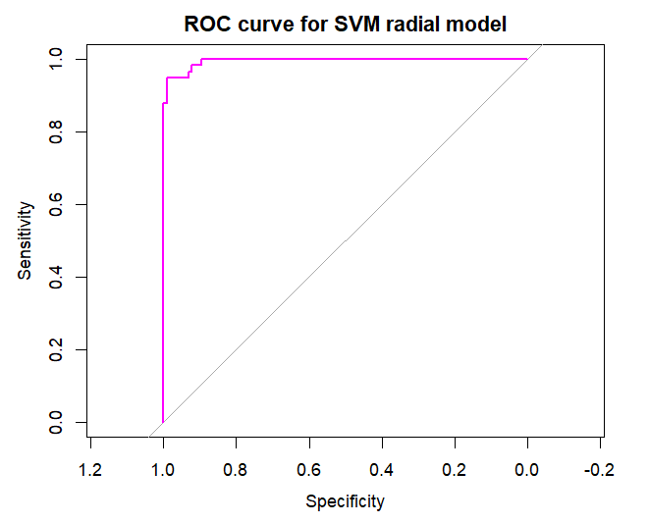

Where:
- True positives: 53 cases where malignant diagnosis was correctly predicted as malignant
- True negatives: 114 cases where benign diagnosis was correctly predicted as benign
- False positives: 1 case where benign diagnosis was incorrectly predicted as malignant
- False negatives: 3 cases where the malignant diagnosis was incorrectly predicted as benign
The predictions in the heatmap, along with the accuracy and the AUC values highlight the good model performance on the prediction of the breast cancer diagnosis, with an accuracy of 97.09%. This evaluation was performed on the test set. Then the same was done on the train set to evaluate for overfitting:
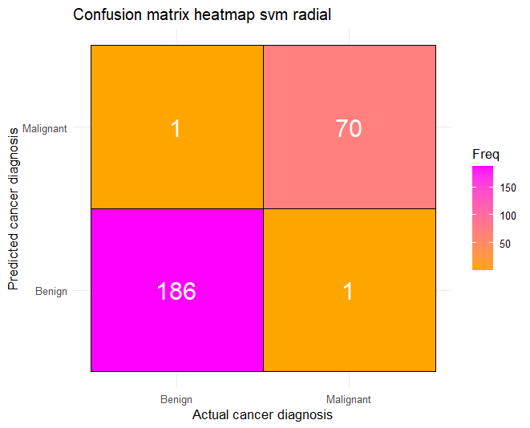
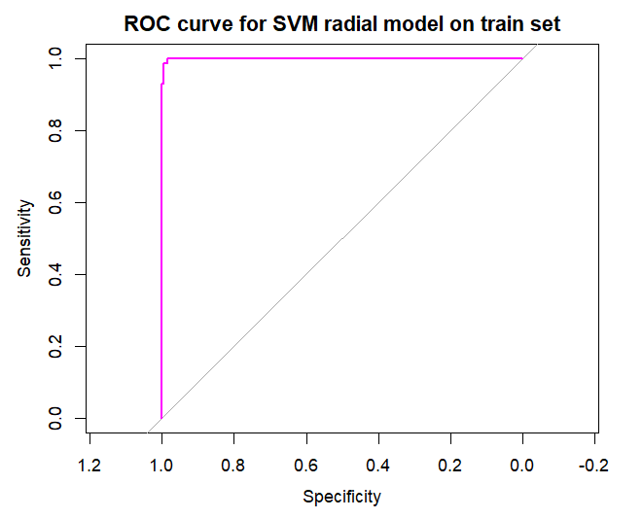

So, the performance on the train and test set are quite like each other, although the one on the train set is slightly higher than the one on the test set. Since the final performance is evaluated in the test set, this confirms that the model still generalises well to unseen data and it’s capable to distinguish well between malignant and benign cases of breast cancer diagnosis.
Comparison of the supervised learning models used for the analysis
Now, to identify which of the models has highest accuracy and it’s the most suitable for our classification purpose on the breast cancer diagnosis, a comparison between their accuracy and ROC curves was made.
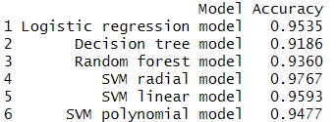
- Accuracy of the models

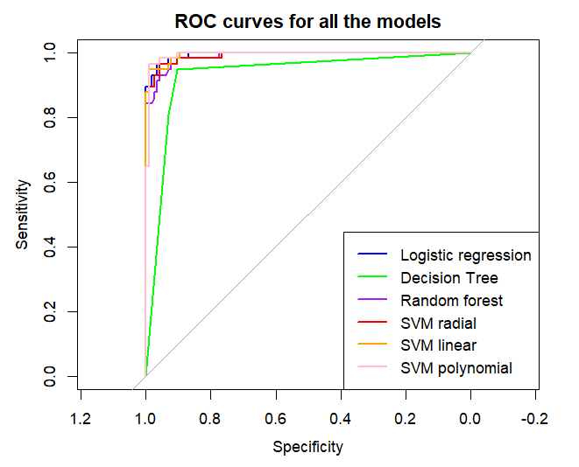
- AUC values and ROC curves

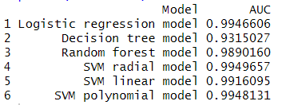

By evaluating both the ROC values and the accuracy of each model used in the analysis, the Support Vector Machines (SVM) algorithm with a radial basis function is the most accurate among all of them having an accuracy of 97.67% and an AUC (area under the curve) value of 0.9949.

